Dear applicant,
In order to register for this module you need to work through our on-line application form. This should take approx. 15minutes.
Please note – you are only able to submit one application per module. One application for multiple modules will not be accepted and you will need to reapply for each module individually.
As part of this application, you will need to upload a copy of your completed study leave approval form. Please ensure your study leave approval form is signed by your CWD lead. Information on CWD leads can be found at the following webpage: https://madeinheene.hee.nhs.uk/cwd/Contact-us-and-useful-information. If you do not attach your approval form to your application or it is incomplete this will delay your application being processed and may impact you being offered a place on the module. Before completing your application please ensure you have the study leave approval form saved to your computer by scanning it into a file, or on your desktop. If you have a smart phone – the app iScanner will allow you to take a photo and converts it to a PDF ready to be saved.
We advise you to refer to this document while you complete the application form.
Once you have found the module you wish to apply for on the Northumbria University website and have checked that the module is being delivered in the month you wish to join, click “book now” to start your application. As the page loads you may get a long yellow and white bar along the bottom of your screen asking ‘do you want to show all content?’ please click ‘yes’. You will be directed to a new webpage that has links to each month for the 2019/0 Academic year. Please ensure the module you would like to undertake is running in the month selected. This information should be on the module webpage, however if you require clarification please contact the Applicant Services (NSBackOffice@northumbria.ac.uk).
Your webpage should look like this:

- Click the black ‘new user’ box on the right hand side. You will be presented with the following screen:

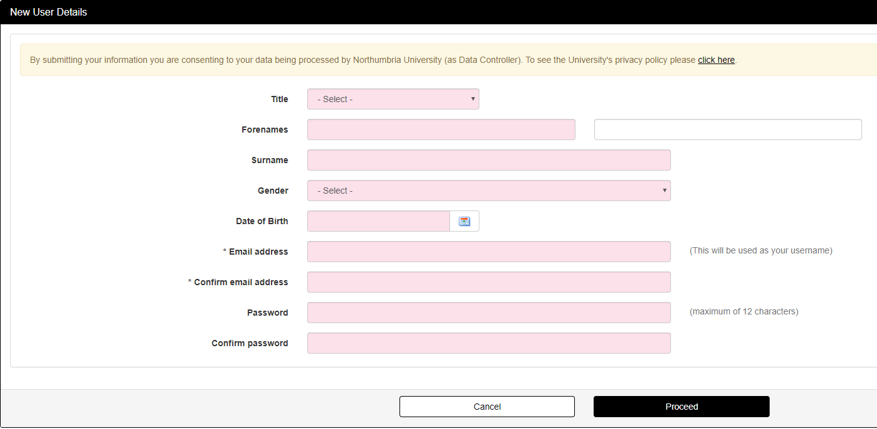

All fields on the screen are mandatory, so please ensure you have completed all fields before clicking “proceed”. Please enter the email address you would access regularly, such as your personal email address.

If you have previously made an application or been a student of Northumbria University, you should be able to login using your previous username and password. If you are unable to remember your password please click “forgotten password” and follow the steps to reset.

If you have any issues accessing an application please contact NSBackOffice@northumbria.ac.uk

- The next page will have some tabs, as below, across the top. Please note at this point and throughout you can save and go back to the application at any time by using your log in details.
Personal details: please complete this section
Education: Please complete this section and add scanned copies of any certificates you may have access to.
At this stage you will be required to upload a copy of your study leave approval form. You can do this in the section that reads “please upload scanned copies of your transcripts and certificate, relevant to your application. Please upload these in PDF format and as one file if possible”.
If you do not upload a copy of your study leave approval form your application may not be considered.
Work Experience: Please add details of any work history for the last 3 years (if applicable).
Module Option Choices:
In this section you will be presented with a drop down list of modules that are running for the month you have selected. Please ensure you select the correct module, and that you select one module only. If an application contains multiple module requests it will not be considered.
Additional information:
Please use the information in this section to specify the source of your funding. If you are a non-NHS employee and are applying for a module under the widening access policy, please send us an email (NSBackOffice@nothumbria.ac.uk) to let us know. We will check that your organisation is included in the policy and will be in touch if we require any further information.
Authorisation:
Please supply the name and address of your CWD Lead. If you are applying for a mentorship module please also supply the details of your PPF. If you are unsure of who your CWD lead is you can find this information on the HEE webpage: https://madeinheene.hee.nhs.uk/cwd/Contact-us-and-useful-information. Details on PPFs can be found at the following webpage: https://www.northumbria.ac.uk/study-at-northumbria/planning-your-career/careers-and-employment/placements/practice-placements/nursing-midwifery-and-odp/contact-information/
When your application is submitted an email will automatically be sent to the named individual.
Declaration: Please read and tick you accept the statement – and submit your application.
You have now completed your application, congratulations. Please look out for an email from Northumbria University regarding your place on the module and information on the Applicant Portal. Please ensure you also check your junk mail.
Should you have any problems please contact Applicant Services via email: NSBackOffice@northumbria.ac.uk

