Continuing Workforce Development/Single Module Registration Guidance Notes
Dear applicant,
In order to register for this module you need to work through our on-line application form. This should take approx. 15minutes.
Please note – you are only able to submit one application per module. One application for multiple modules will not be accepted and you will need to reapply for each module individually. This is part of the contractual requirement the University has with Health Education England North East (HEENE).
As part of this application, you will need to upload add the details of your CWD lead as a reference. Details on how to do this are included in the “referees” section below. Failure to add the details of your CWD Lead will lead to delays in your application being processed and may impact your place on the module. This is part of the contractual requirement the University has with Health Education England North East (HEENE).
Before completing your application please ensure you have any qualifications (where required as part of the entry requirements) saved to your computer by scanning it into a file, or on your desktop. If you have a smart phone; the app iScanner will allow you to take a photo and converts it to a PDF ready to be saved.
We advise you to refer to this document while you complete the application form.
Once you have found the module you wish to apply for on the Northumbria University website and have checked that the module is being delivered in the month you wish to join, click “book now” to start your application.
As the page loads you may get a long yellow and white bar along the bottom of your screen asking ‘do you want to show all content?’ please click ‘yes’.
You will be directed to a new webpage that has links to each month for the 2020/1 Academic year. Please ensure the module you would like to undertake is running in the month selected. This information should be on the module webpage, however if you require clarification please contact Applicant Services -NSBackOffice@northumbria.ac.uk
Click the black ‘new user’ box. You will be presented with the following screen:
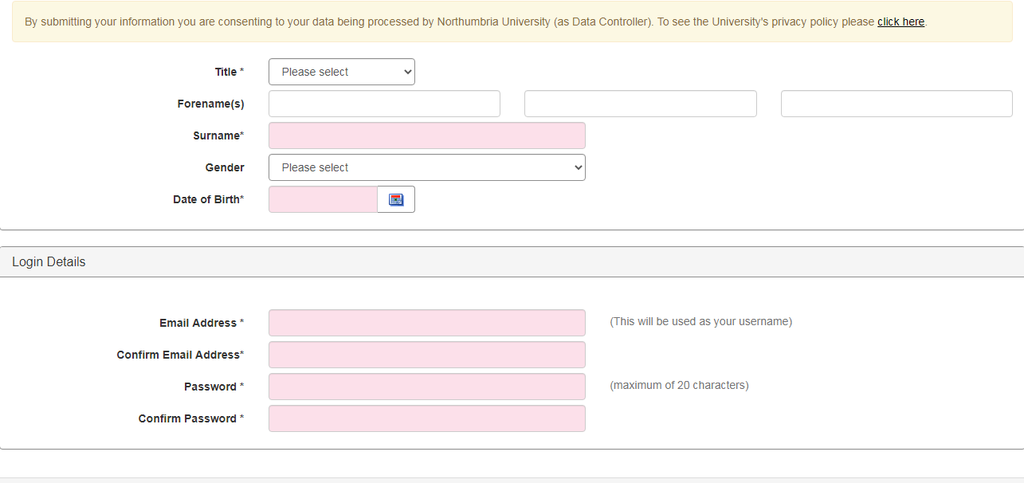

All fields on the screen are mandatory, so please ensure you have completed all fields before clicking “proceed”. Please enter the email address you would access regularly, such as your personal email address. Please ensure the email address you enter is accurate as all communication regarding your application will be sent to this address. If it is incorrect you will not receive updates on your application and risk missing out on a place.
If you have previously made an application or been a student of Northumbria University, you should be able to login using your previous username and password. If you are unable to remember your password please click “forgotten password” and follow the steps to reset.
If you have any issues accessing an application please contact NSBackOffice@northumbria.ac.uk
Personal details
Please complete all sections on this page.
Contact Details
Please complete all sections on this page.
Module Selection
In this section you will be presented with a drop down list of modules that are running for the month you have selected. Please ensure you select the correct module, and that you select one module only. If an application contains multiple module requests it will not be considered.
Qualifications
Please complete this section and upload scanned copies of any certificates you may have that satisfy the entry requirements of the module where required (for example, if applying for a level 7 module you may be asked to provide evidence of study at level 6).
Please note – we do not require GCSE or A-Level Certificates. We only require certificates related to the entry requirements for the module.
If you do not upload evidence of your qualifications at application stage this may cause delays in your application assessment. If your qualifications are in a different name, please also ensure you upload evidence of your name change, such as marriage certificate, deed poll documentation etc.
To upload a qualification go to the “Qualification document upload” section, click “select documents” and find the document you would like to upload. Once you have found it, double-click, and the document should appear on your application. If you upload an incorrect document, you can click “delete” to remove.
Experience
Please use this section to upload details of your current employment.
If you are applying through the Continuing Workforce Development (CWD) policy and are securing funding for your module through your Trust please ensure in the section titled “Employer name and address” you enter the full address for your employer but also the name of your Trust. This is vital in ensuring the correct Trust is invoiced for your fees. Failure to add the name of your Trust will lead to delays in your application being processed and may risk your place on the module. If you are unsure of your Trust please speak to your employer in the first instance. If you are still unsure please contact the Applicant Services team – NSBackOffice@northumbria.ac.uk
You can add previous employment by selecting “Add another role”. In the Professional Memberships section of the page please select “Yes”, add the name of the Professional Body (such as NMC), and add your Registration PIN.
Referees
In this section you will be required to give the details of your CWD Lead as a reference.
Please note – we do not require details of anyone else (such as your line manager).
When submitting your application an email will automatically be generated to the person named in this section. It is vital that the details in this section are those of your CWD Lead. Without their authorisation we cannot progress your application and you will not be given a place on the module. Details of the CWD Leads for each Trust are available at the following webpage https://www.northumbria.ac.uk/business-services/cwd-authorisers/
When completing this section of the application form please complete as follows:
Type of reference: Professional
Title, forename and surname: Detailed on the CWD Lead webpage
Position: CWD Lead
Institution/Company: The name of the Trust – detailed on the CWD Lead webpage.
Email address: Detailed on the CWD Lead webpage. It is vital the email address is entered correctly. If the email address entered is incorrect your CWD Lead will not receive an email and this will cause delays with your application.
Country: England
Funding
If you are securing your funding through your Trust/CCG please select “sponsor/employer”. If you are paying your own fees or are securing funding outside of the CWD policy please select “self/family”. If you are unsure of who is paying your fees and would like some clarification please speak to your employer in the first instance. If you are still unsure please contact the Applicant Services team – NSBackOffice@northumbria.ac.uk
Submission
Please read this section in full and tick the box to confirm you have read, understood, and agree to the statements included on the page. Click submit.
You have now completed your application, congratulations. Please look out for an email from Northumbria University regarding your place on the module and login details for the applicant portal. Through the applicant portal you can view the status of your application. If any information is missing from your application or you are made a conditional offer you can respond and upload any documentation via the portal. Should you have any problems please contact Applicant Services via email: NSBackOffice@northumbria.ac.uk

