Dear applicant,
To register for this Programme you need complete an online application form. This should take approximately 15 minutes.
As part of this application, you will need to upload a copy of your completed study leave approval form. You can find this on the Programme webpage. The form requires completion by 5 individuals; you (the applicant), an authoriser/appropriate other, your Prescribing lead, your Practice Supervisor and your Practice Assessor. If you do not attach your approval form to your application or it is incomplete this will delay your application being processed and may impact you being offered a place on the Programme. Before completing your application please ensure you have the study leave approval form saved to your computer by scanning it into a file, or on your desktop. If you have a smart phone – the app iScanner will allow you to take a photo and converts it to a PDF ready to be saved.
We advise you to refer to this document while you complete the application form.
Click “book now” to start your application. As the page loads you may get a long yellow and white bar along the bottom of your screen asking ‘do you want to show all content?’ please click ‘yes’. You will be directed to a new webpage that has links to both the January 2020 and March 2020 intakes. Please ensure you click the link to the application for the cohort you would like to join.
- Click the black ‘new user’ box on the right hand side. You will be presented with the following screen:

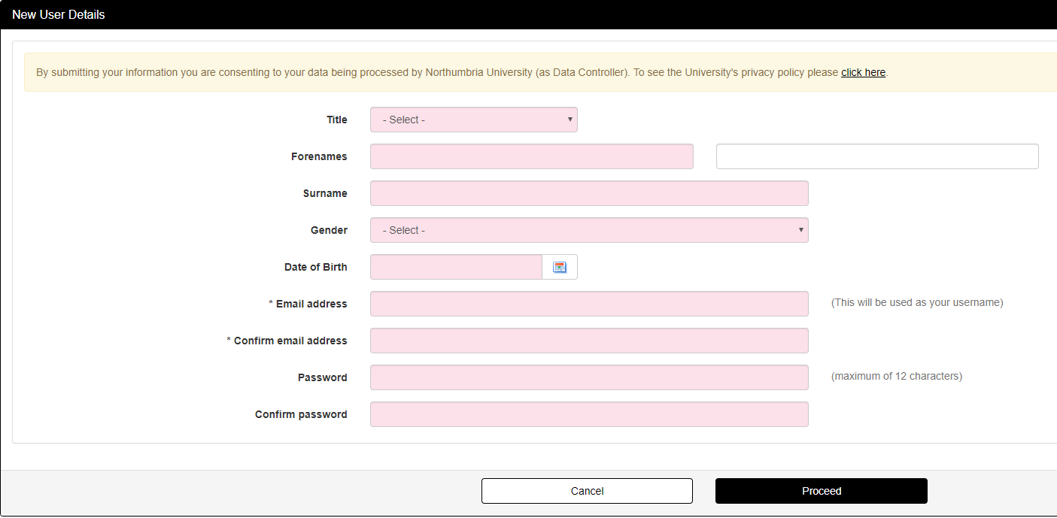

All fields on the screen are mandatory, so please ensure you have completed all fields before clicking “proceed”. Please enter the email address you would access regularly, such as your personal email address.

If you have previously made an application or been a student of Northumbria University, you should be able to login using your previous username and password. If you are unable to remember your password please click “forgotten password” and follow the steps to reset.

If you have any issues accessing an application please contact NSBackOffice@northumbria.ac.uk
Before starting your application you will notice there is a “checklist”, enabling you to check for any sections of your application that are not complete.
Personal Details: Please complete this section
Contact Details: Please complete this section
Qualifications: Please complete this section and remember to upload evidence (such as a completion certificate) with your application. If you are unable to find the relevant “subject” on the application form, please enter “health”. We will be able to see the specific qualification from your uploaded qualifications. You can also upload a copy of your completed Study Leave approval form at this stage.
Work Experience: Please add details of any work history for the last 3 years (if applicable). You can also use this section to upload a copy of your most recent DBS check. Please note – your DBS certificate must have been issued within 3 years of your application being submitted. If you do not have a valid DBS please do not submit an application and arrange to have a new DBS undertaken. Once this is confirmed please complete your application. On the application you will be asked “Do you have a professional body membership?” Please answer “yes” and give the name of the Professional Body (NMC) and give your NMC PIN. Please ensure your PIN is accurate as we will be using this to verify your registration. If your PIN is incorrect this may delay your application and impact on your place on the Programme.
Referees: Please use this section to give the details of your authoriser/appropriate other
Funding: Please use the information in this section to specify the source of your funding. If you are being funded please select Sponsor/Employer. If you are funding yourself please select self/family.
Submission: Please read and tick you accept the statement – and submit your application.
You have now completed your application, congratulations. Please look out for an email from Northumbria University regarding your place on the Programme and information on the Applicant Portal. Please ensure you also check your junk mail.
Should you have any problems please contact Applicant Services via email: NSBackOffice@northumbria.ac.uk

