An Applicant Guide
Main Screen View
This is what you will see when you log in.
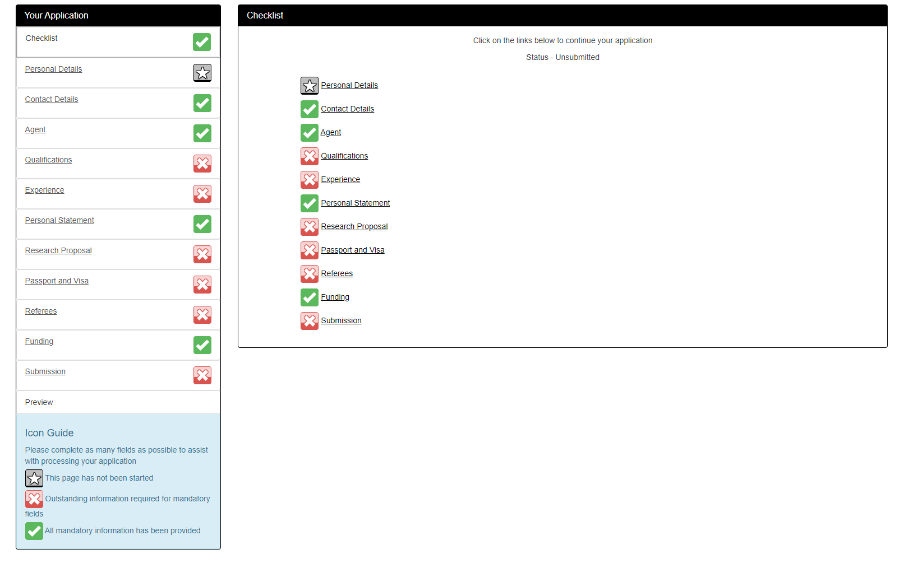
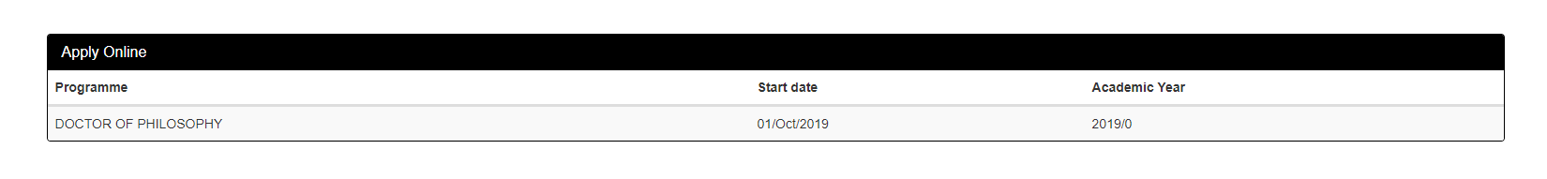

ICON Guide

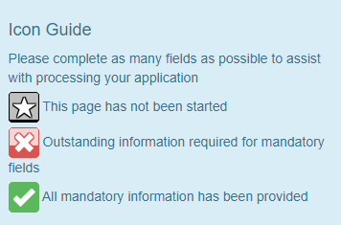
It’s important to note that the ICONs respond to information required for mandatory fields. The white tick on a green background is a measure of mandatory compliance and does not indicate or confirm that the information is accurate, appropriate, relevant and purposeful.
KEY POINT: The white tick on a green background is a measure of mandatory compliance and does not indicate or confirm that the information is accurate, appropriate, relevant and purposeful.

Checklist
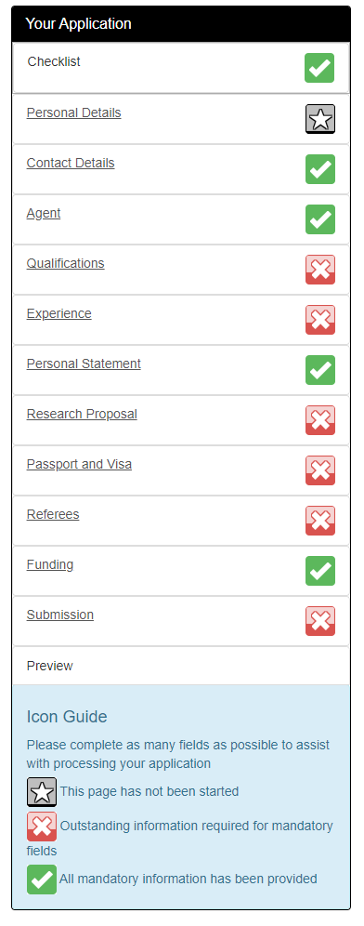
As it ‘says on the tin’ the checklist is just that. In this case, an interactive, fit for purpose checklist that will automatically offer you prompts and instruction (e.g. Uploads) as you complete the form.

Save and Continue
On each section you will need to click either ‘Save’ or ‘Save and continue’. This saves your work!
KEY POINT: Save and continue after each section

Preview and Submit
Please note that once you click on the ‘Submit’ button when you have finished your application the form is submitted and cannot be retrieved to add more details and/or a document or other upload evidence.
So, please follow the the S P S rule prior to any submission!
SPS
STOP - PREVIEW – SUBMIT
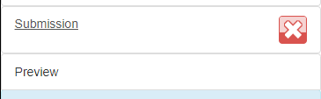
Please always click the preview button before the submission button. With a mind-set of ‘Right First Time’ you can ensure an efficient application process

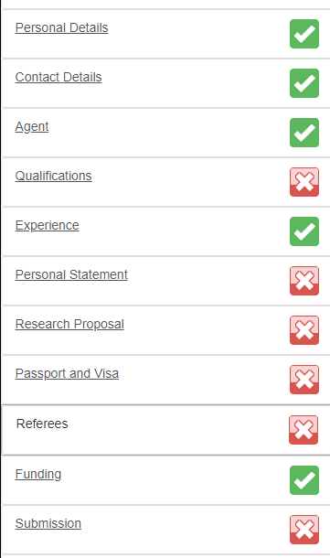
An alternative to the preview button is to click on each menu selection and carefully check all data input.
Please ensure that only the appropriate documents are uploaded in the appropriate sections.
Please do not upload all evidence in one document and then apply multiple uploads across sections!

Uploads
Uploads will be required for certain sections and within those sections the Online Application Form OLAF, may ask you for an upload depending on what information is added. For example in the ‘Personal Statement’ section you can complete your personal statement by typing directly into the text box. If you choose this option then an upload will not be offered. If you decline this option then the OLAF will request an upload of a pre-written personal statement. It is recommended you prepare and upload your personal statement as opposed to typing ditrectly into the text box.
Example:
Click on Personal Statement
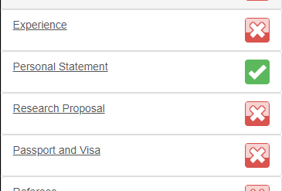

If you select ‘No’
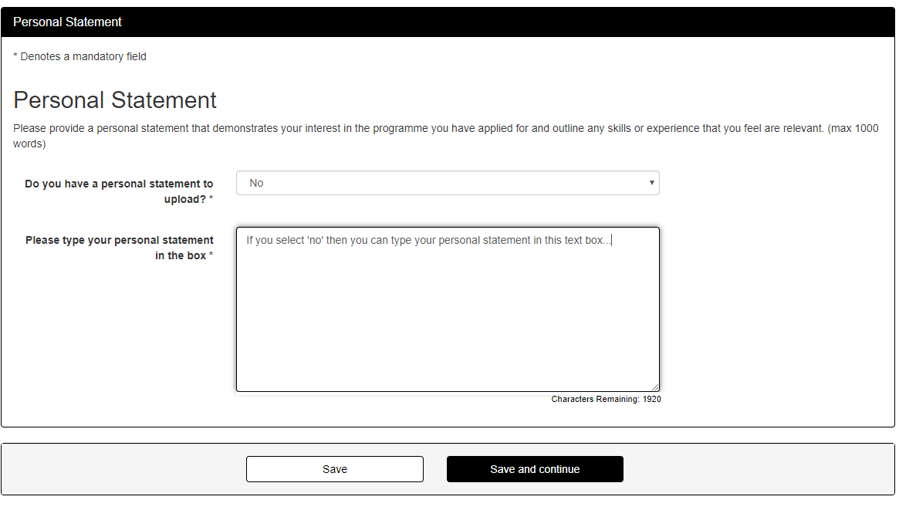

If you select ‘Yes’
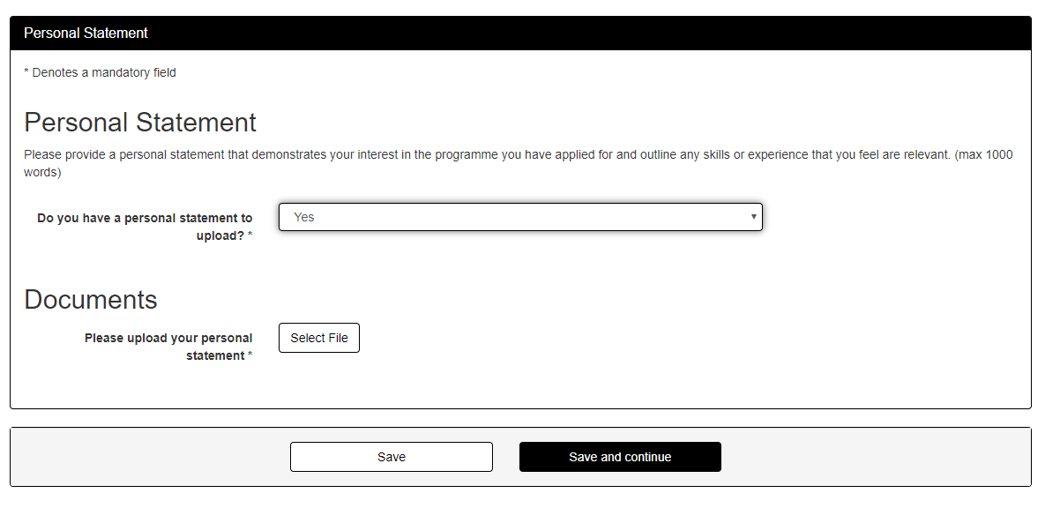

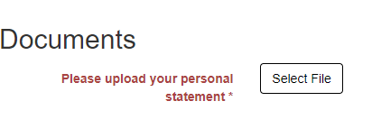

Click on Select File
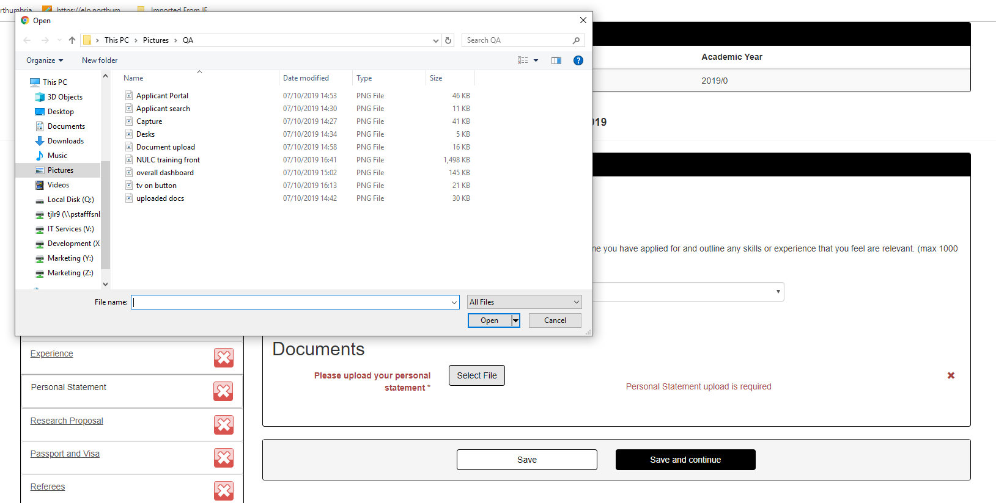
So you can see that this example offers a prompt (mandatory) to upload your personal statement. Where there is a mandatory prompt and/or instruction, the OLAF will highlight the command in red and in doing so offer you a reminder.
General Navigation
The form is very intuitive and each menu section will guide you through different data entry/upload pathways which will change depending upon the data entered. Where there are mandatory fields, then these will be highlighted in a different font colour upon the clicking of the ‘Save’ or the ‘Save and continue’ buttons.
Example of a Navigation Pathway
Click on Qualifications
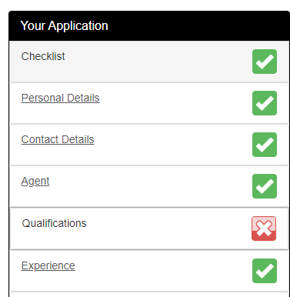
Enter field data in first section
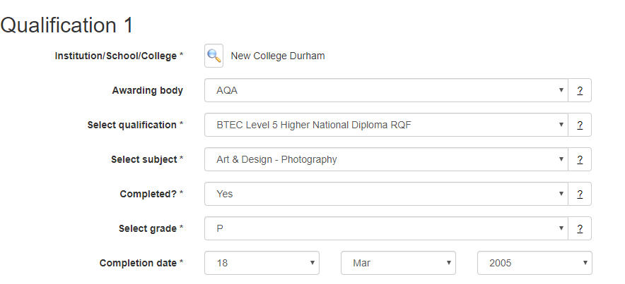

If there are other relevant qualifications to the application then click
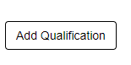
Enter field data in new section
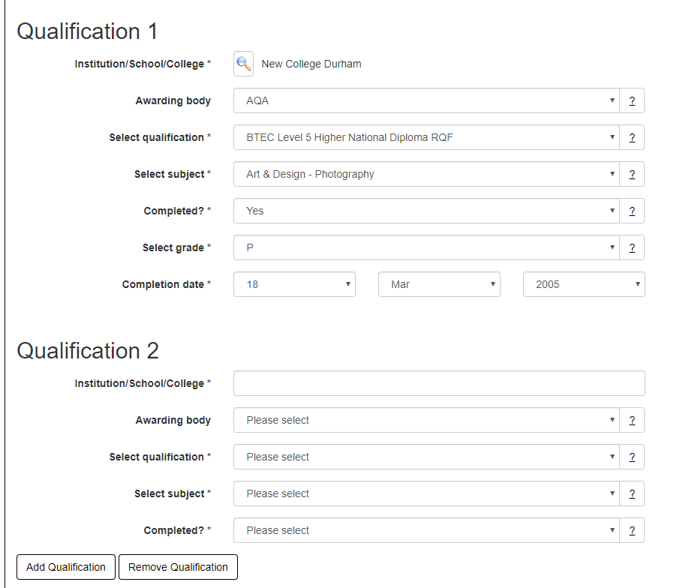
Once all qualifications have been entered then click Qualifications document upload
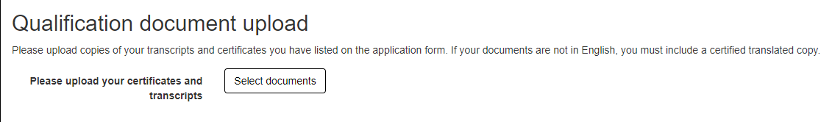

Browse and select
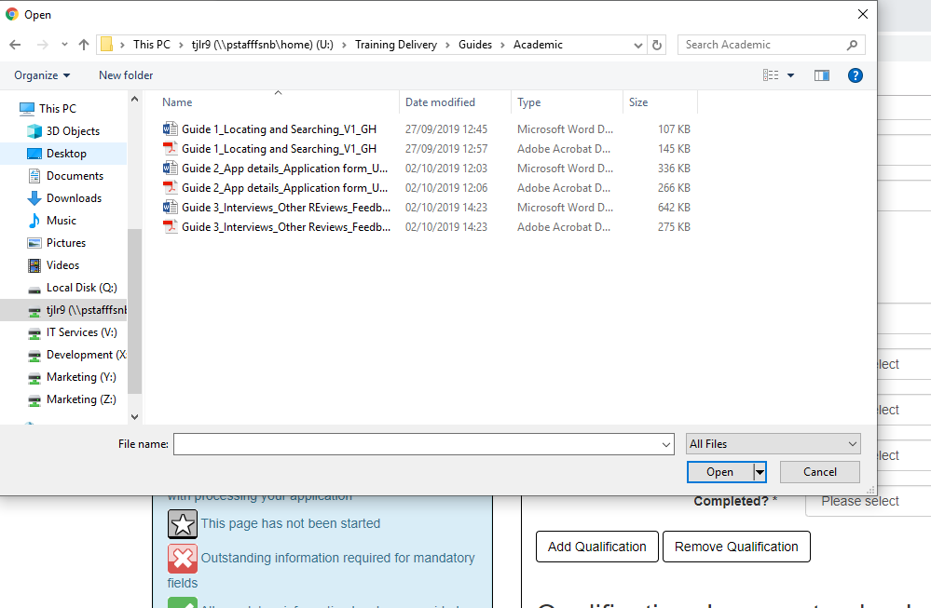
Select and click Open
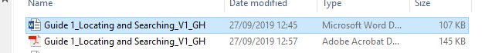
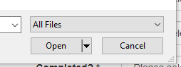
And wait just a few seconds
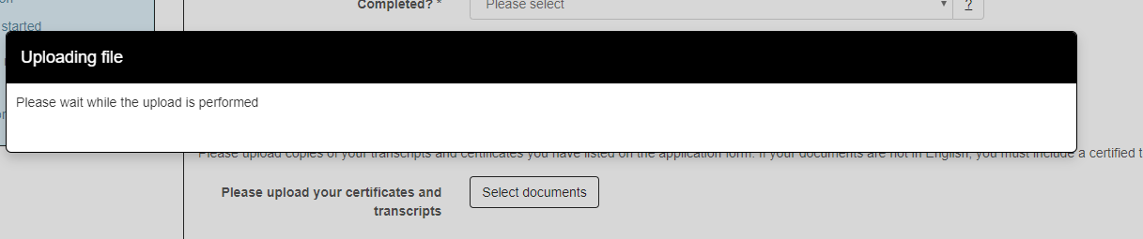
Ensure that the doc format is….
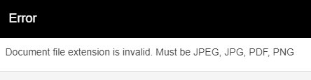

Required document will be displayed here
