Northumbria University
Medicine, Science and Justice Day, 28th June 2018
A one-day seminar for professionals and academics demonstrating the contribution of science and medicine to complex cases and problems in the justice system internationally
0830-0900 | Registration
0900-0910 | Welcome
0910-1000 | Cannibalistic Homicide in England and Wales  Alfredo Walker (University of Ottawa, Canada)
1000-1100 | Forensic science contribution to the Stephen Lawrence and Joanna Yates inquiries  Kelly Sheridan (Northumbria University, UK)
1100-1130 | Refreshments
1130-1230 | The contribution of forensic anthropology to medico-legal investigation  Martin Evison (Northumbria University, UK)
1230-1400 | Lunch
1245-1345 | Lunchtime Discussion and Q&A  Medical Assistance in Dying (MAID) in Canada  A discussion of medico-legal and ethical issues and principles following the Supreme Court of Canada ruling that an absolute prohibition on medical assistance in dying sought by competent adults, who are suffering intolerably from grievous and irremediable medical conditions, violates their rights and is unconstitutional, and the passage into law of Bill C-14 protecting medical practitioners from criminal prosecution.  Chairs: Michelle Robson and Kristina Swift (Northumbria University, UK)  Discussion Panel: Alfredo Walker (University of Ottawa), Others TBC
1400-1445 | Blood pattern analysis: demonstrating the role of BPA in an exoneration case  Gillian Leak (Principal Forensic Services, UK)
1445-1530 | Medico-legal and ethical aspects of the diagnosis of violence against children in Brazil  Marco Guimarães (University of São Paulo, Brazil, TBC)
1530-1630 | Seeking Answers to the Burning Question: Review of a Fire Death in German Police Cell  Alfredo Walker (University of Ottawa, Canada)  In 2005, the burnt body of an asylum seeker was found shackled by both wrists and ankles to a mattress in a police cell in small German town. From the onset, the case was treated as self-inflicted burn injury and was investigated as such until it was externally reviewed by a team of British experts many years later in 2013. The presentation will review the forensic and medico-legal evidence that was flowed out of the initial investigation and how that review influenced a change of opinion by the German authorities.

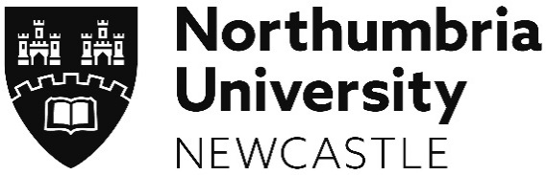 | Faculty of Business and Law: Science and Justice Research Interest Group, Medical and Mental Health Law Research Interest Group, Northumbria Centre for Evidence and Criminal Justice Studies; Faculty of Health and Life Sciences: Forensic Science Unit
Contact: nucfs@northumbria.ac.uk

