SAFETY / ENVIRONMENTAL Near Miss / Hazard report card
- Don’t dismiss a near miss  - Prevent an incident before it occurs  - A Near Miss could be the next injury  - Report hazards |  |  |  |  | 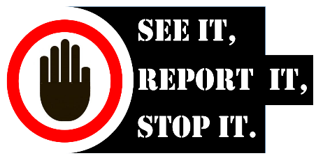
What is a Hazard? |  |  |  | What is a Near Miss?
A Hazard is something with the potential to cause harm to people or the environment. Examples: could be a slippery surface, sharp edges, a leaking container, damaged equipment, missing guard on a machine. All of which are likely to injure someone if not removed, made safe or repaired. |  |  |  | An actual event which occurred which could have caused actual harm or damage to people, the environment or equipment.  Examples: An object falls and misses you as you walk by. A handbrake fails and the vehicle rolls backwards hitting a bollard. A fence blows over into a walkway.
SAFETY |  | x |  | ENVIRONMENTAL |  |  | x
NEAR MISS: |  |  |  | NEAR MISS:
HAZARD: |  |  |  | HAZARD:
Name:  (not mandatory) |  |  |  | Phone No.
Near Miss location:

Date: |  | Do you wish to receive feedback? Yes ☐ No ☐
What did you see?
What could have happened?
Is the area safe now? Yes ☐ No ☐
You may need to call Security to attend the area on Ext:3200
How can we avoid this happening again?
What do you think needs to be done?
Attach photographs here: (if on line)

Attach photographs here:

Please forward this form to the Health and Safety Team or Sustainability advisor (Email/hard copy)
For SAFETY related contact:  CRhealthandsafety@northumbria.ac.uk |  |  |  | For ENVIRONMENTAL related contact:  Katie.a.ridley@northumbria.ac.uk
Health and Safety / Environmental Team ONLY
Level of Risk / Priority posed by hazard? (Tick) | High |  | Med |  | Low

Actioned by: |  |  | Close out Date:
Action taken / Feedback Given:

UNN/H&S/F/020 30/04/2018 V2

