Research Briefing | 
supporting outdoor businesses
A summary of our workshop at Northumbria University by Gary Bosworth, Leanne Townsend, Rikke Brandt Broegaard & Simon Laing

Our collective research in Denmark, North East England and Scotland has revealed a huge variety of rural entrepreneurs that practice their businesses in outdoor spaces. This includes culinary heritage and food and drink experiences, adventure, art and crafts, wellbeing and other nature-based activities. They are usually very small and sometimes run on a part-time basis so often fall under the radar of business support and local tourism policies. However, grouped together, they make a significant contribution to regional and rural economies. They also play a role in place-making, creating and sharing different representations of outdoor spaces and the rural communities and landscapes in which they are set.  This briefing introduces our emerging area of applied rural research and extends and invitation to get involved. |  | 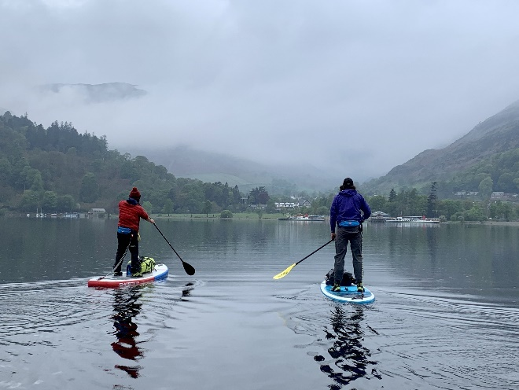


why this matters
Rural economies are changing with a growing diversity of small firms reducing the traditional dominance of agriculture and primary industries. Demand for outdoor experiences has been growing as an antidote to stressful working lives, and reflecting growing awareness of environmental issues, particularly among Generation Z.
This research investigates the policies and business practices that can enable “outdoor entrepreneurs” to build successful businesses and create more value in their local area. We define them as business owners who draw value from outdoor spaces in the performance of their business. Specifically, we need to understand the distinctive business models, collaborations and marketing strategies that are most effective in this growing area of rural business.

REsearch findings
Business operators in this sector are passionate and skilled at what they do, and that passion and knowledge often has a strong association with place. On the Danish island of Bornholm, many of these were return migrants or incomers who were able to identify experience-based opportunities differently to local residents. In our UK research, we also identified major potential for collaborations between businesses to create new visitor experiences and to combine local traditions and skills with an outward-facing perspective towards emerging market demands.
Outdoor entrepreneurs in North East England and Scotland spoke a lot about the importance of social media. The ability to tell stories about their work, share images of experiences and places, and communicate freely and directly with (potential) customers has enabled substantial growth in this sector. It is perhaps ironic that a lot of these activities are presented as off-line, mindful, and more connected to traditional lifestyles. Outdoor businesses have developed a range of strategies to manage the pressure of updating and responding to social media. Some employ experts to manage it for them, thereby avoiding the “split personality” challenge, while others set aside defined times for posting content. Among those comfortable with managing an online persona, the ability to share content through their client base and other collaborative businesses enhances its impact – both for their business and potentially for the renewal of the place brand of the wider area.
Many of these businesses are operated as part of lifestyle choice, or to provide a secondary income alongside other employment. They are often highly collaborative in their local niche area, but the scope for wider collaboration and more strategic marketing is sometimes limited. Therefore, business advice must be at a scale that is right for each individual business and the different aspirations of their owners. Business advisors and policy frameworks also need to recognise these as serious businesses. This can deliver benefits at different scales – for individual business confidence, for cluster development and for the wider promotion of destination regions.
In the case of craft businesses on Bornholm, the creation of a professional association at the regional level, and the business support’s recognition of the importance of sector-specific knowledge, helped makers to feel more comfortable in adopting a business persona, and made them more visible to policymakers. Rather than hobbyists, they are now treated as innovative small businesses.

Recommendations
As the research develops, we are keen to run smaller workshop events in the countryside to make it easier for more businesses to participate. In a similar vein, it is essential that organisations like the Rural Design Centre continue to explore new approaches to supporting the sector.
The research team is looking to develop a wider international network to share good practices and to explore regionally distinctive examples of rural outdoor businesses across Europe. Also, through direct collaboration with policy and business support organisations, we are advocating steps to develop the sector further. Some of those ideas, along with ways you can get involved, are over the page.

For policymakers and business support organisations:
- Treat outdoor businesses as a distinctive sector, with specific needs and opportunities.
- Explore approaches that can raise their profile. For example, the Bornholm Craft Business model could for adapted to promote outdoor experiences and skills.
- Use appropriate language to recognise passion-driven and not just growth-driven businesses.
- Develop regional networks to enhance collaboration and facilitate more joint marketing approaches.
- Recognise the use of, and experiential values derived from rural and outdoor spaces in methods of valuing rural assets and determination of land-use planning priorities.
- Consider new forms of start-up advice, or outdoor business incubators to continue to grow the sector.
- Continue to invest in rural infrastructure to ensure mobile and broadband coverage is available for these businesses.

WHAT NEXT, AND HOW YOU CAN GET INVOLVED…
We are currently writing a paper based on the first stage of the research, which has been supported by the Northumbria University’s research development fund. If anyone from the North East of England or North East of Scotland would like to participate, please do get in touch as we are still looking for more case studies.
We will be applying for new funding to expand the reach of the research very soon. If you work in another region and would like us to include you in these plans, we would love to hear from you.
Finally, we are seeking funding to develop a Europe-wide network of academics, policymakers and practitioners under the COST Action Scheme that supports collaboration across all fields of research. This seeks to draw together a range of examples of good practice, opportunities and challenges from contrasting regional contexts. Potentially, we could also explore outdoor businesses operating in urban areas here too so please do share ideas, challenges and questions that we can try to address through this continuing work.

About us:
Gary Bosworth (gary.bosworth@northumbria.ac.uk) is a Professor of Rural Entrepreneurship at Northumbria University. His research focuses on changing rural economies and communities, with particular emphasis on migration and commuting patterns, new ways of working, urban-rural interdependences, and the roles that businesses play in shaping the contemporary countryside.
Leanne Townsend (leanne.townsend@hutton.ac.uk) is a Senior Social Scientist at James Hutton Institute. Her research explores rural economic development with a special focus on the role of digital tools and online platforms. She is currently particularly interested in the ways in which nature-based and traditional rural skills are being built into rural entrepreneurship.
Rikke Brandt Broegaard (rbb@crt.dk) is a Senior Researcher at the Centre for Regional and Tourism Research in Denmark. Her research focuses on rural development, place-embedded niche businesses, place effects of mobility and multi-local actors, empowerment, collaboration and collective action, including rural-urban connections, power and resilience.
Simon Laing (simon.laing@ruraldesigncentre.com) is a Rural Business Advisor at the Rural Design Centre. Simon typically supports small business owners and self-employed people in Northumberland, England with starting up, diversifying and growing their rural enterprise. He is also an experienced adventure sports leader and coach; he continues to operate a small business in this space.

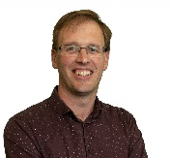

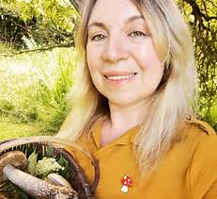

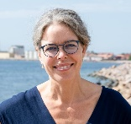

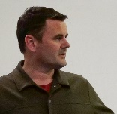

For Outdoor Businesses:
- Look for local collaborations that can add value to the experiences that you already offer.
- Try to balance the consistency needed to meet people’s expectations with the need to keep innovating to satisfy demands for increasingly novel experiences.
- Make sure you and your social media is on the radar of regional tourism & business development organisations.
- Think about the work that only you can do – where your presence and skills are essential – and whether other tasks can be outsourced.
- Distinguish between the activities that attract the most profitable market sectors and the activities that you want to provide for other reasons – which may be for local social value, your own enjoyment or to promote the business in new ways.
- Don’t be a slave to social media (but recognise its value in reaching out to potential clients and expanding your networks)
- Don’t compromise on your quality and values.

