Alcatel IP Desktop phone – Quick Reference Sheet 2025
 |  | Scan QR code for video.
Taking a new call  Press the New Call button to take a new call. The callers’ details will appear in the window as well as an animated phone icon. | 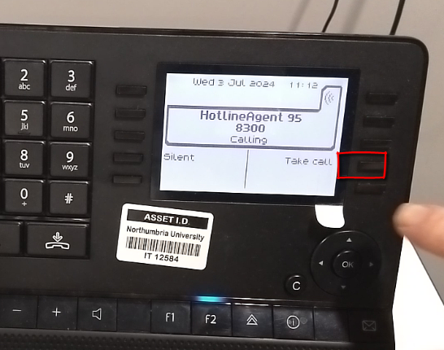 | 
https://northumbria.cloud.panopto.eu/Panopto/Pages/Viewer.aspx?id=805a5a3f-0e03-4070-bc5f-b1a3009ff048

Adjusting the headset volume  You can use the plus and minus keys on the desktop to adjust the headset volume. | 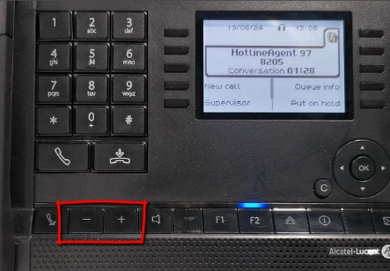 | 
https://northumbria.cloud.panopto.eu/Panopto/Pages/Viewer.aspx?id=1ad5b5bf-671e-41cd-90a9-b1a000a9e4e1

Available / Unavailable  When you first login, you will be Unavailable. This is shown by a filled tick box.  Press the Unavailable button to make yourself available to take calls.  Where you are available, there will be no tick box. | 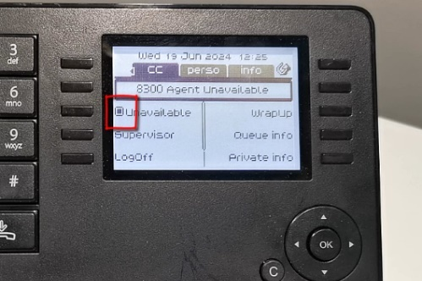 |   
https://northumbria.cloud.panopto.eu/Panopto/Pages/Viewer.aspx?id=e886e3f0-c139-40fd-b58b-b1a000ab7597

Transferring a call – warm transfer  To transfer a call press New Call then dial the 4 digit faculty extension number. You can then provide some context before transferring the call.. | 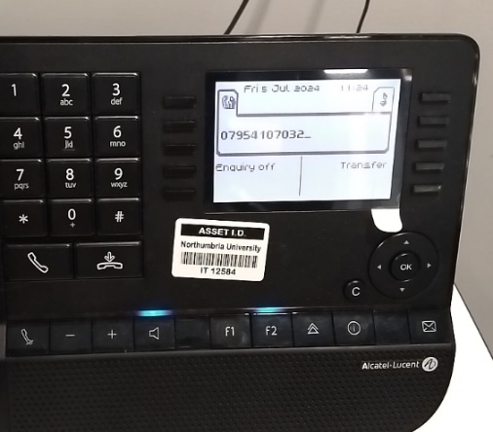 | 
https://northumbria.cloud.panopto.eu/Panopto/Pages/Viewer.aspx?id=a4c87197-a0c4-4adc-b33a-b1a700938f3b

Putting a caller on hold  Press Put on Hold to put a caller on hold, while on hold they will hear music and will not be able to hear you.  Press Retrieve call to take the caller off  on hold.  Note: It is better to put a caller on hold rather than mute them. | 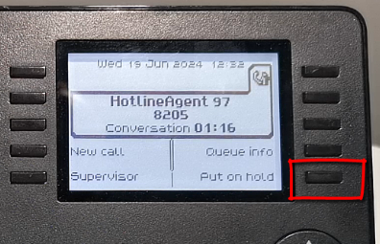 | 
https://northumbria.cloud.panopto.eu/Panopto/Pages/Viewer.aspx?id=302f54b6-c3b7-4923-be2c-b1a300851833
Make an external call whist being unavailable.  Press the Unavailable button to make yourself available to take calls. The tick box will appear to indicate you are unavailable.  To make an external call, press 9 followed by the number you wish to call. | 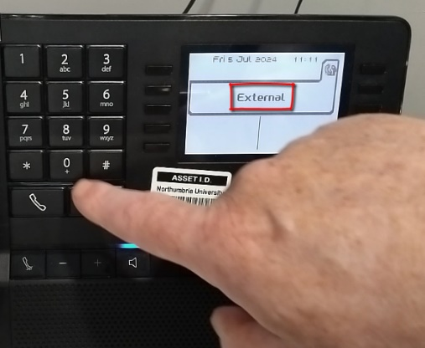 | 
https://northumbria.cloud.panopto.eu/Panopto/Pages/Viewer.aspx?id=77f57b1d-315e-439f-ab9e-b1a7008441d5

Suspend Call Recording  During a call press F1 then *3. Press Deactivate DTMF to Return to main menu.  To re enable call recording press F1 followed by *7. Press Deactivate DTMF to Return to main menu. | 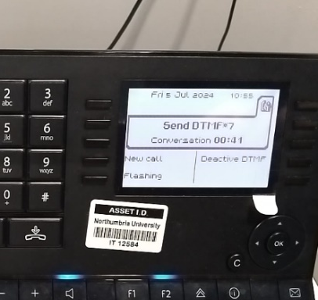 | 
https://northumbria.cloud.panopto.eu/Panopto/Pages/Viewer.aspx?id=98e21d8c-c471-45a0-81db-b1a7007b7d60

