
Northumbria University is a research-intensive, modern university with a proud heritage of making a difference to individuals and to society. We have a global reputation for academic excellence, and are proud to have been recognised as:


Northumbria is a challenger institution, transforming to take on tomorrow by putting students at the heart of an outstanding experience. It is our mission to change lives through education and research, tackling the global challenges of our age to transform society and the economy.


Contents
Purpose of this document 4
1 The context of AMHP education and practice 6
1.1 The Mental Health Act 1983 6
1.2 The AMHP role 6
1.3 AMHP statutory and regulatory frameworks 7
1.4 The AMHP workforce 8
2 AMHP education at Northumbria University 9
2.1 Programme position and security 9
2.2 Equality, Diversity and Inclusion 9
2.3 Support for students 10
2.4 Programme staff 10
2.5 Lived Experience Involvement 11
2.6 Programme governance and quality assurance 12
2.7 Performance 12
2.8 Complaints 14
3 PG Cert AMHP structure and delivery 15
3.1 Programme Structure 15
3.2 Time commitment 16
3.3 Practice learning 16
3.4 Indicative schedule for 2026/27 17
3.5 Programme capacity and prioritisation of places 18
3.6 Tuition fees 19
3.7 Independent Applicants 19
4 Application criteria and process 20
4.1 Application process 20
4.2 Entry requirements 20
4.3 Selection process 22
4.4 Accepting an offer and enrolling to study 22
Appendix 1 Step-by-step guide to the online application process 23
Appendix 2 Personal Statement 28
Appendix 3 Practice Learning Audit Checklist 29
Appendix 4 Confirmation of Financial Sponsorship 32

Purpose of this document
The challenging, demanding, and ethically complex AMHP role necessitates challenging, demanding, preparatory training, which must be approved as meeting the Social Work England (SWE) AMHP course standards This document provides comprehensive information for sponsoring agencies and potential applicants to Northumbria University’s Post Graduate Certificate Approved Mental Health Professional (PG Cert AMHP) programme.

Section 1 – The context of AMHP education and practice: Provides information to help you make an informed choice about whether you are ready to become an AMHP.
Section 2 – AMHP education at Northumbria University: Provides information to help you make an informed choice about studying at Northumbria University.
Section 3 – PG Cert AMHP structure and delivery: Provides details of the commitment involved in studying Northumbria University’s PG Cert AMHP.
Section 4 – Application criteria and process: Sets out the entry requirements and application and selection process.
Appendices: If you decide to make an application, PLEASE read the appendices which set out step-by-step exactly what you need to do.

Please do not hesitate to contact me to discuss any individual circumstances or questions that you have.
Dr Cathryn Meredith
AMHP Programme Academic Lead
Cat.meredith@northumbria.ac.uk

The context of AMHP education and practice

1.1 The Mental Health Act 1983
The provisions of the Mental Health Act 1983 (MHA) address the reception, care, and treatment of mentally disordered people, the management of their property and other related matters. In doing so, they present powers to:
Authorise detentions depriving people of their liberty in hospital, police custody, or prison.
Convey, assess, and treat people against their will.
Compel people to be subject to guardianship or supervised treatment in the community.

In 2017, the government commissioned an Independent Review of the Mental Health Act. The subsequent report Modernising the Mental Health Act (2018) recognised that both the Act itself, and the practice which emanates from it, require a change of culture. The report made more than 150 recommendations, fundamentally emphasising the importance of human rights in mental health care, and the urgent need for effective collaboration between services and people from all cultures and communities who experience mental health needs. Some of these recommendations have been incorporated into the recently passed Mental Health Act 2025 which significantly amends the 1983 Act, and therefore will significantly alter AMHP practice.

1.2 The AMHP role
The Approved Mental Health Professional (AMHP) role is pivotal within the MHA, and is recognised as one of the most important in the whole system mental health (DHSC1, 2019). AMHPs are responsible for coordinating and leading complex, inter-agency MHA assessments (MHA Code of Practice,14.41), and only AMHPs have powers to make applications - when appropriate - for someone’s civil detention in hospital, or compulsory guardianship in the community.

AMHP practice is a relational, values-based, and political activity which presents the opportunity to challenge discrimination, and promote rights, choice, autonomy, and individual recovery. AMHPs’ statutory duties and powers are by design independent from, rather than subordinate to, medical opinion (Walton, 2010). Operating from a social model (DHSC2, 2019) under an imperative to safeguard civil rights, AMHPs draw from social and medical evidence, exercising their own independent judgement to determine whether or not there are alternatives to detention and compulsion under the MHA (Hemmington, Graham et al., 2021). Whilst AMHPs act on behalf of local authorities (LAs), as the MHA Code of Practice (14.52) asserts, ‘they cannot be told by the local authority or anyone else whether or not to make an application.’

Inarguably, social and mental health systems are under enormous pressure. Assessment delays, lack of community provision, and shortage of appropriate inpatient beds mean people in mental health crisis do not always receive the service quality they should expect, and impact the morale of the AMHP workforce (DHSC, 2018). AMHPs, however, are resourceful, resilient, and tenacious, and many are harnessing their knowledge and expertise collectively to drive change from within social and mental health systems. The Critical AMHP forum has established an impetus and a space to reflect on AMHP practice, share ideas about what impedes and what can motivate it, and collectively lobby for change. AMHPs are finding novel and ethical ways of undertaking and publishing research on their often-unseen role, generating practice-based evidence of the unique situations its encounters, its impact, and how it can develop. In 2024, the AMHP Leads Network launched a discussion paper, ‘New’ Practices Within Existing Law. The renewed enthusiasm of the existing AMHP workforce makes this is an incredibly exciting time to consider becoming an AMHP!

1.3 AMHP statutory and regulatory frameworks
The PG Cert AMHP is externally approved by the specialist regulator of AMHP education, Social Work England (SWE). SWE’s AMHP course standards set expectations that AMHP education is rigorous, relevant to current mental health practice, and well-prepares students to carry out AMHP statutory duties under the Mental Health Act. SWE annually monitors the standard and quality of the PG Cert AMHP and periodically reviews the programme against its standards for reapproval purposes.

Social Work England’s AMHP course standards are designed to ensure that students who successfully complete an AMHP course can meet the requirements set out in the Mental Health (Approved Mental Health Professionals) (Approval) (England) Regulations 2008. Schedule 1 of these regulations restricts the AMHP role to:
- social workers currently registered with Social Work England
- Mental health or learning disability nurses currently registered with the Nursing and Midwifery Council
- Occupational therapists currently registered with the Health and Care Professionals Council
- Chartered psychologists who hold a relevant practising certificate issued by and are currently registered with the British Psychological Society.

Schedule 2 of the regulations sets out matters LAs must take into account to determine competence before approving someone under s.114 MHA to act as an AMHP. Competencies are arranged under five headline areas:
Key Competence Area 1: Application of Values to the AMHP Role.
Key Competence Area 2: Application of Knowledge: The Legal and Policy Framework.
Key Competence Area 3: Application of Knowledge: Mental Disorder.
Key Competence Area 4: Application of Skills: Working in Partnership.
Key Competence Area 5: Application of Skills: Making and Communicating Informed Decisions.

1.4 The AMHP workforce
Key to LAs ensuring that they have sufficient AMHPs to carry out their statutory duties is succession planning which incorporates a long-term, inclusive view of workforce development needs. Skills for Care’s 2025 AMHP Network Survey estimates currently 3,800 AMHPs are approved in England, but 10% are inactive, and only 27% of the remainder operate on a full-time basis, giving an actual number of around 1,600 full-time equivalent AMHPs.

The Department of Health and Social Care National Workforce Plan for AMHPs highlights the relatively limited demographic of AMHPs and the need for LAs to strive to better serve communities through greater diversity. Currently, 79% of AMHPs in England are of white ethnicity, and the Northeast, this figure rises to 93%. We strongly support all efforts diversify the northeast’s AMHP workforce.

2 AMHP education at Northumbria University

2.1 Programme position and security
Northumbria University is incredibly proud to have been delivering programmes to support the development of the values, knowledge, and skills needed for AMHP practice for over 30 years. The PG Cert AMHP is a level 7 (postgraduate) programme which runs for a complete academic year. It is the only SWE approved AMHP programme in the Northeast of England region. It is delivered within the Faculty of Health and Wellbeing’s School of Communities and Education, which is focussed on high quality professional education, research and innovation across multiple disciplines including social work, social care, public health, occupational therapy, childhood and early years, and the many facets of education. The programme’s future is secured by its alignment to the School’s aims of challenging educational, social, and health inequalities, and championing social justice through teaching, research and innovation.

2.2 Equality, Diversity and Inclusion
The PG Cert AMHP is conscious of the need for a diverse AMHP workforce and actively encourages applications from any motivated candidate from the prescribed professional groups who is likely to benefit from and contribute to the programme’s challenging and stimulating learning environment.

We are proud of our diverse, multi-cultural University which is enriched by a student body that is reflective of the wider community through the inclusion of people from all social and ethnic backgrounds, ages, genders, disabilities, and sexual orientations. Equity of opportunity and choice are core to our educational mission, and we are determined to ensure that the opportunities we provide are open to all. We have a strong commitment to raising educational aspirations in the Northeast, which has one of the lowest rates of Higher Education participation nationally and hosts some of the most income deprived local authority areas in the UK.

2.3 Support for students
Our Student Accessibility Team provides tailored support to any students with a condition which meets Equality Act (2010) criteria, such as physical health conditions, sensory impairments, specific learning differences (SpLD) including dyslexia and ADHD, social or communication differences such as an autism spectrum condition, or long-term mental health conditions. Reasonable adjustments and any other arrangements which can ensure students can thrive at University are agreed through a personalised Student Accessibility Plan (SAP).

Neurodiversity is supported and celebrated within our communities through a series of 1-1s, drop-ins and events under our Neurodiversity@Northumbria banner. Our Counselling and Mental Health Team also offer a number of options - from self-help resources to one-to-one appointments - to support students’ mental health and wellbeing during their time at Northumbria University. Our Specialist Student Support Team provide specific support for pregnant students and new parents returning to studies, including dedicated spaces for parenting. We see wellbeing as related to all dimensions of a person’s being: cultural, social and spiritual as well as physical, emotional and academic. Our Spiritual Care Team helps explore perplexities of meaning and direction in life through spiritual life-coaching or spiritual accompaniment and includes chaplains who can offer students a listening ear, encouragement, and prayer.

2.4 Programme staff
The PG Cert AMHP is staffed by AMHP experienced academics, and teaching, tutoring, oral examinations, and assessment of practice learning is supported by currently practising AMHPs from across the region. The core teaching team comprises:

Academic Lead: Dr Cathryn Meredith, Assistant Professor, registered social worker SW077772 cat.meredith@northumbria.ac.uk
Overall academic responsibility for the programme lies with Cathryn (Cat). Cat qualified as a social worker in 2001 and practised across a breadth of adult mental health settings as an Approved Social Worker (ASW), AMHP, and Mental Capacity Act Best Interests Assessor (BIA). She joined Northumbria University in 2013, and her teaching takes a primary focus on critical and social approaches to mental distress, rights-based practice, mental health law, and inclusion and co-production research. As a researcher, Cat collaborates with people with lived experience to undertake ethnographic, naturalistic enquiries.

Professional Lead: Chris Hardy, Associate Lecturer, registered social worker SW30621 christopher.q.hardy@northumbria.ac.uk
Chris brings vital practice wisdom, currency, and professional authority to the PG Cert AMHP programme. He draws from 30 years of experience of operating under the MHA as an ASW, AMHP, and AMHP manager across our region. Chris remains a practising AMHP and AMHP team manager, and through his long-standing tenure as an Associate Lecturer, collaborates with the academic lead to professionally guide all aspects of the PG Cert AMHP from admissions to teaching, tutoring, practice learning, governance, and fitness to practice.

Dr Carole Southall, Assistant Professor, Registered social worker SW16162 carole.southall@northumbria.ac.uk
After qualifying in 1987, Carole became an ASW in 1990. She went on to manage a community mental health team, and as a local authority ASW lead, was very involved in developing and establishing Northumbria University’s first ever ASW programme in 1992. Carole joined Northumbria University in 2007, where her teaching focuses on adult practice and mental health law, and her research uses interpretive phenomenological analysis to explore how practitioners make sense of their lived experiences. Carole leads Northumbria University’s Post Qualifying Social Work programme and is involved in all modules of the PG Cert AMHP.

2.5 Lived Experience Involvement
The programme proceeds from the stance that AMHP education, like AMHP practice, must challenge dominant narratives and received wisdom, and respect and learn from the traditionally marginalised experiences, perspectives, and knowledge of those who have lived experience. Our Lived Experience Lead, Steve O’Driscoll is involved in all aspects of the course design, delivery, and governance to ensure that this commitment is upheld. He and other lived experience educators share their knowledge, views, and experiences across the programme to support students to critically explore contemporary issues in mental health.

2.6 Programme governance and quality assurance
The Northeast AMHP Leads Forum - The Programme Leader attends the Northeast AMHP Leads Forum to discuss the PG Cert AMHP’s design, delivery, and efficacy, and review its performance with the agencies who sponsor practice learning arrangements. This knowledge exchange forum helps to ensure the curriculum remains abreast of and responsive to the changing needs of communities and the AMHP workforces serving them and provides the opportunity to understand current demands across the region so that places on the PG Cert AMHP can be allocated fairly. Significant findings are reported up to Northumbria University’s Social Work Programme Committee. Members of the Northeast AMHP Forum are invited to attend the university annually for an end of year programme review.

External Examination - an AMHP academic independent of Northumbria University is appointed as the programme’s External Examiner (EE), whose role is to scrutinise assessment tasks and provide the academic programme leader with critical feedback which ensures they are fit for purpose, fair, and robust. A sample of all summatively assessed work is moderated by the EE to ensure that programme marking is fair, consistent, and provide students with helpful and constructive feedback. The EE reports on the quality of the course annually to the Programme Assessment Board.

Programme Assessment Board - all module results are provisional until they have been presented to the Programme Assessment Board (PAB) at the conclusion of the programme’s teaching and assessment cycle. The PAB considers student results within the ARTA framework to ensure that fair and equitable assessment has taken place. Once the PAB determines and confirms marks, eligible students are awarded the PG Cert AMHP, resit opportunities are authorised for students who have not passed module/s at their first attempt, and failures are confirmed for students who are not eligible for further attempts.

2.7 Performance
The PG Cert AMHP programme’s continual quality, development, and improvement are dependent on understandings of its efficacy in preparing students for AMHP practice. Current and meaningful data is collected for analysis via:
Student representation - each cohort is asked to elect a student representative who meets, as standard, twice a year with the programme lead, module academics, and academic support staff to share feedback from the student body. Outside of these scheduled meetings, student reps are encouraged to freely share any feedback or issues with the academic lead as they arise. Student reps are also invited to attend the Programme Management Committee.

Student feedback – feedback is invited during teaching, and students are made aware that all module academics can be contacted via email. In addition to sharing feedback via the elected student representative, students are invited to participate in anonymous programme level surveys where they rate 8 different aspects of their teaching and learning experience from 1 to 5, where higher scores indicate more positive responses.

Lived experience educator and practitioner feedback – the programme leader actively seeks feedback from people with lived experience who work as educators on the programme and practitioners who are involved with the programme.

Performance data is shared at the Social Work Programme Committee, and the School Education Strategy Meeting so that trends in relation to student numbers, EDI considerations, academic performance, and student satisfaction can be identified. Areas of good practice and required actions are fed back to the programme team, and any agreed actions are monitored. We are very proud that across all aspects, the PG Cert AMHP receives a consistently high level of student satisfaction, as the results of the 2025/26 survey below demonstrate:


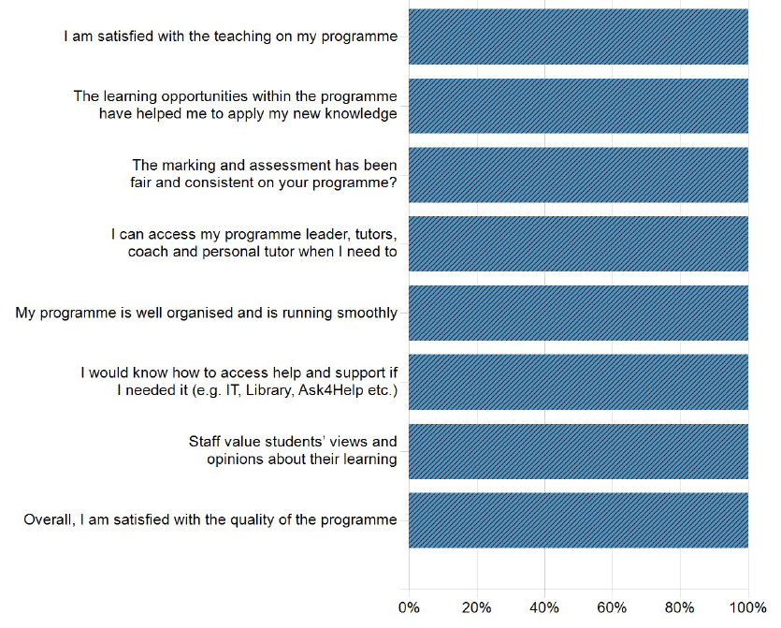

2.8 Complaints
Whilst we strive to ensure that the student experience at Northumbria is a positive one, students are entitled to make a complaint if dissatisfied with the way they have been treated or with the standard of a service provided by or on behalf of the University. Our staged approach to resolving student concerns, complaints, and appeals is detailed in the Handbook of Student Regulations.

3 PG Cert AMHP structure and delivery

3.1 Programme Structure
The programme runs annually, commencing in September and concluding with the PAB in June. Students who work part time hours may elect to work towards a later exam board. The PG Cert AMHP is awarded to candidates who successfully complete three, consecutively taught modules, each of which carries 20 academic credits at level 7.

3.2 Time commitment
Students are required to attend 16 days of teaching which comprise an induction day, then 5 taught days per module. Module SW005 is assessed by an in-person law oral examination which takes place on campus and lasts for approximately 45mins. The PG Cert AMHP is necessarily academically demanding, and students need to be able to protect time to undertake self-directed learning, reading, and preparation for summative assessments. We recommend that in addition to enabling their staff to attend teaching, sponsoring agencies facilitate a minimum of 15 protected study days across the programme lifespan.

3.3 Practice learning
Practice learning is aligned to the programme’s third module, where concurrently with attending university teaching, students must complete a minimum of 40 days/300 hours in a mental health setting under the supervision of an experienced AMHP who will assess their practice. Applicants to this course must be able to demonstrate that a Local Authority has agreed to sponsor them to complete a minimum of 40 days (300hours) of AMHP practice learning under the supervision of a qualified and experienced practising AMHP. Sponsors are required to complete a Practice Learning Audit Checklist (see Appendix 3) describing the proposed arrangements, which should be submitted as part of the application. These proposed arrangements must be quality assured by the Academic Lead in conjunction with the Practice Placements team to ensure they will comply with legislative and regulatory requirements, and reflect Northumbria University’s duty of care to our students before a place is offered.

Each student enrolled on the PG Cert AMHP is allocated an AMHP experienced academic tutor, who will offer support and advice, ensure an appropriate practice learning agreement is constructed, and work with the student and their AMHP practice assessor to review progress against the regulatory competencies for AMHP approval.

3.4 Indicative schedule for 2026/27
The programme is delivered at Coach Lane Campus. If you intend to make an application to the PG Cert AMHP, please protect the following dates in your diary now. Any changes to dates/times will be communicated as swiftly as possible.
Content |  | Date and time | Assessment
Programme induction |  | Tuesday 08/09/26, 10-4 | N/A
SW7004  Contemporary Themes in Mental Health | Day 1 | Tuesday 15/09/26, 10-4 | 3,000word assignment  Due by:  23:59 Thurs 19/11/26
SW7004  Contemporary Themes in Mental Health | Day 2 | Wednesday 16/09/26, 10-4 | 3,000word assignment  Due by:  23:59 Thurs 19/11/26
SW7004  Contemporary Themes in Mental Health | Day 3 | Tuesday 22/09/26, 10-4 | 3,000word assignment  Due by:  23:59 Thurs 19/11/26
SW7004  Contemporary Themes in Mental Health | Day 4 | Tuesday 29/09/26, 10-4 | 3,000word assignment  Due by:  23:59 Thurs 19/11/26
SW7004  Contemporary Themes in Mental Health | Day 5 | Wednesday 30/09/26, 10-4 | 3,000word assignment  Due by:  23:59 Thurs 19/11/26
SW7005  Mental Health Law | Day 1 | Tuesday 24/11/26, 10-4 | Oral examinations will take place over  Thursday 04/03/27 and Friday 05/03/27  Individual dates and times to be confirmed
SW7005  Mental Health Law | Day 2 | Tuesday 01/12/26, 10-4
SW7005  Mental Health Law | Day 3 | Tuesday 08/12/26, 10-4
SW7005  Mental Health Law | Day 4 | Tuesday 05/01/27, 10-4
SW7005  Mental Health Law | Day 5 | Tuesday 12/01/27, 10-4
SW7006  Assessment & Planning under the Mental Health Act | Day 1 | Tuesday 02/02/27, 10-4 | 4,000word assignment Due by:  23:59 Thurs 20/05/27
SW7006  Assessment & Planning under the Mental Health Act | Day 2 | Tuesday 09/02/27,10-4 | 4,000word assignment Due by:  23:59 Thurs 20/05/27
SW7006  Assessment & Planning under the Mental Health Act | Day 3 | Tuesday 16/02/27, 10-4 | 4,000word assignment Due by:  23:59 Thurs 20/05/27
SW7006  Assessment & Planning under the Mental Health Act | Day 4 | Tuesday 16/03/27, 10-4 | 4,000word assignment Due by:  23:59 Thurs 20/05/27
SW7006  Assessment & Planning under the Mental Health Act | Day 5 | Tuesday 06/04/27, 10-4 | 4,000word assignment Due by:  23:59 Thurs 20/05/27
A minimum of 40 days/300 hours practice learning must be completed between 04/01/27 and 14/05/27. Practice learning CANNOT take place outside of this established window without prior negotiation with the programme’s Academic Lead. |  |  | Practice Learning Portfolio  Due by:  23:59 Thurs 20/05/27

Students, AMHP practice assessors, and tutors are invited to attend the first of the online practice learning workshops detailed below. The second is for AMHP practice assessors and tutors only, and students are not required to attend:

Online over Teams | Outline of Content
Workshop 1  Tuesday 15/12/26  10-11.30a.m. | This workshop takes place before the practice learning window opens, to support students and AMHP practice assessors to understand  - regulatory requirements including the AMHP competencies and duty to share fitness to practise information  - meeting and evidencing module requirements in the practice learning portfolio document, with a focus on identifying learning needs and opportunities, completing the practice learning agreement, supervision and tracking progress, and how to access support.
Workshop 2  Wednesday  17/02/27  10-11.30 | For AMHP practice assessors ONLY.  - To access pooled knowledge on supporting and supervising students to meet learning needs.  - Advice will be given on how to conduct an optional mock law oral examination, and a previous exam paper will be provided.

3.5 Programme capacity and prioritisation of places
A maximum of 30 places are available each year, and demand fluctuates - some years the programme runs with a small cohort, whilst in others it runs at full capacity. The PG Cert AMHP programme exists to meet the northeast’s AMHP workforce needs, and individual local authorities will establish what these are, and undertake their own internal selection processes to decide which and how many of their staff they will sponsor to apply to the PG Cert AMHP. To allow available places to be responsively and equitably distributed across the region, it is crucial that AMHP/Workforce Development leads advise the programme leader of how many applicants they anticipate sponsoring.

Following our selection process all applicants who meet the entry requirements will be offered a place. The programme may not be viable if less than 12 students take up offers of places, and in these circumstances, the university reserves the right to defer it until the next academic year. If more than 30 applications meet the entry requirements, LA sponsored applications will be given priority over non-LA or self-funding applicants. If necessary, the programme leader will ask the Northeast AMHP Leads Network to determine where the greatest workforce need is and then allocate available places accordingly. Applicants who meet the entry requirements but are not offered a place because of high demand will be given the opportunity to roll their application over to the next academic year.

3.6 Tuition fees
Total fees for the PG Cert AMHP in academic year 2026/27 are £3,233.

3.7 Independent / Self-funding Applicants
We welcome applications from anyone who can meet the eligibility criteria for entrance to AMHP education. If you are considering studying the PG Cert AMHP under the financial sponsorship of an agency which is not a local authority, or on a self-funding basis, please contact the programme’s academic lead, cat.meredith@northumbria.ac.uk to discuss the practicalities of this before making an application. Northumbria University cannot make practice learning arrangements on your behalf, but we may be able to put you in touch with relevant AMHP Leads for you to have these discussions yourself.

4 Application criteria and process

4.1 Application process
Applications for the next academic year open at the conclusion of teaching on the current cohort (usually April/May). The application cycle closes on 31st July.

Applications are made via our online applicant portal. A link to this can be found in Appendix 1 of this document, along with step-by-step guidance on how to complete your application in order to demonstrate the entry requirements set out at 4.2. PLEASE follow the guidance - it demonstrates exactly what is needed and helps you to avoid filling out unnecessary sections. You do not need to complete your application in one sitting, you can create it, save it, and return later to add further information/upload documents. Your application will be managed by Applicant Services, who can be contacted at nsbackoffice@northumbria.ac.uk if you have any questions about it.

Applicant services will ONLY transfer your application to the programme academic team for a decision on whether a place can be offered once your online application is fully completed and submitted along with required supporting documents outlined below in the table at section 4.2. Submitting an application does not guarantee the offer of a place on the programme.

4.2 Entry requirements
The programme has specific entry requirements which comply with statutory and regulatory frameworks for AMHP education and enable the selection of candidates who demonstrate appropriate academic and professional standards. Admissions decisions will be made with integrity, equity, and professionalism through consideration of each candidate’s own merits, abilities, and potential, and sensitively taking into account all known relevant factors relating to previous and likely attainment, and individual needs.

Relevant prior accredited learning under the UK Frameworks for Higher Education Qualifications will be recognised (RPL). Where an applicant has not previously gained academic credits at level 6 or above, they should contact the programme leader for a discussion about whether prior experiential learning can be recognised (RPEL). The table below demonstrates where RPL and RPEL are relevant within the entry criteria.
 | Entry Requirement | Evidenced by
1) Qualification and current professional registration as a social worker, mental health or learning disability nurse, occupational therapist, or clinical psychologist. |  | Uploading a copy of your qualifying degree certificate or equivalent as part of your online application (see Appendix 1).  Providing your professional regulatory body and registration number within the Professional Memberships section of online application (see Appendix 1).
2) Previous study at academic level 6 (undergraduate degree)/equivalent or higher. |  | Information you provide within the Education tab of your online application (see Appendix 1).  If you have not previously studied at level 6 or above, contact cat.meredith@northumbria.ac.uk to discuss RPEL possibilities.
3) A minimum of two years post qualified practice experience by the start of the programme in September 2026. |  | Information you provide within the Work Experience tab of online application (see Appendix 1).
4) A personal statement of no more than 1,500 words setting out how you have potential to acquire and demonstrate the AMHP competencies set out in Schedule 2 of the AMHP Regulations (England). Your personal statement should be grammatically written, and reference appropriate literature.  Or  RPL on the Northumbria University modules SW0740 Law and Practice for Best Interests Assessors or SW7009 Law and Practice for Best Interests Assessors. |  | Personal statements should be uploaded to your online application as a single word/pdf document (See Appendix 2).  Or  Uploading a copy of academic transcript or letter of confirmation to online application as a word/pdf document (see Appendix 1).
5) Details of proposed practice learning opportunity and AMHP practice assessor arrangements. |  | An appropriate person from your sponsoring agency should complete the template provided at Appendix 3 of this document and email it to cat.meredith@northumbria.ac.uk

As AMHP education entails practice learning, there is an entry requirement to provide details of proposed practice learning arrangements, but this is not completed within your online application. You may submit your application pending completion of Appendix 3 of this document by an appropriate person from your sponsoring agency.

4.3 Selection process
Once transferred, your application will be initially reviewed by the programme’s academic lead, who will check your entry in the relevant professional register, and ensure that all entry requirements are met. Personal statements will be reviewed by a panel comprising the academic and professional leads, and the lived experience lead. The lived experience lead will provide all applicants with feedback on their personal statements. If any entry requirements are not met, Applicant Services will contact you to request further evidence. If this is provided before the application cycle close on 31st July, your application will be reviewed again. Once the programme academic team notify Applicant Services that all entry requirements are met, you will be offered a place on the programme.

4.4 Accepting an offer and enrolling to study
Once you receive an offer of a place on the programme, you must accept it or let us know that you do not intend to take it up so that it can be offered to another applicant. All offers are subject to enhanced DBS clearance. Once you have accepted your offer, you will receive instructions on how to complete online enrolment to PG Cert AMHP. As part of this enrolment process, students whose fees will be met by their employer must upload a letter confirming this and providing an invoice address. A proforma letter is available at Appendix 4 of this document.

In all cases, please ensure you complete enrolment in advance of the programme induction so that you gain access to your student e-mail, Blackboard or Northumbria University facilities. Once you have enrolled, you will be contacted by Northumbria University’s DBS team, to begin the enhanced check, and the programme’s academic lead, who will provide details of teaching and learning.

We look forward to welcoming you to Northumbria University!

Appendix 1 Step-by-step guide to the online application process
PLEASE FOLLOW THIS GUIDANCE TO AVOID COMPLETING UNNECESSARY PARTS OF THE ONLINE APPLICATION. If you encounter any problems with the application process, please contact Applicant Services at nsbackoffice@northumbria.ac.uk.

Click on this link:
https://nuweb2.northumbria.ac.uk/live/webserv/ipo.php?code=DTPAMP6&code2=0002
You will be taken to the page below. To begin your application, please just click on the link ‘APPLY FOR SEPTEMBER 2026.’
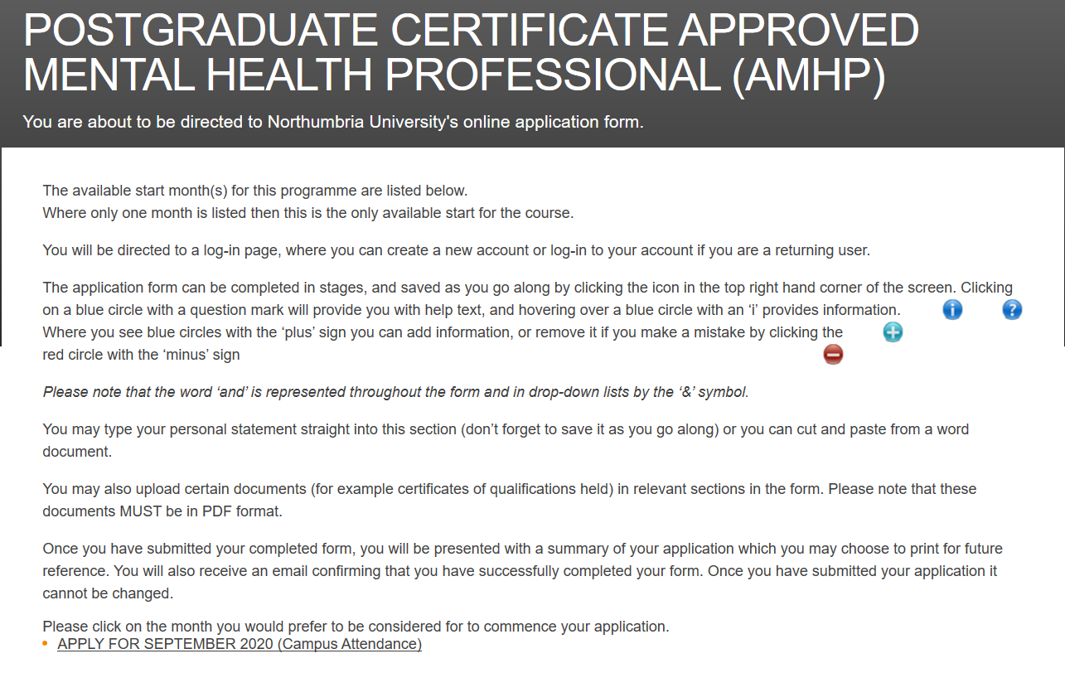

You will be asked to either use an existing applicant login or create a new account. If you have previously applied for a Northumbria University programme through our online portal, please use your existing login.

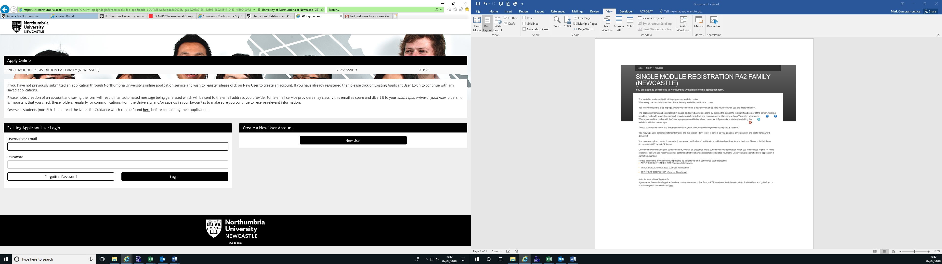

If you have not previously applied to Northumbria University, you will need to create a new account by filling out the details as demonstrated below:
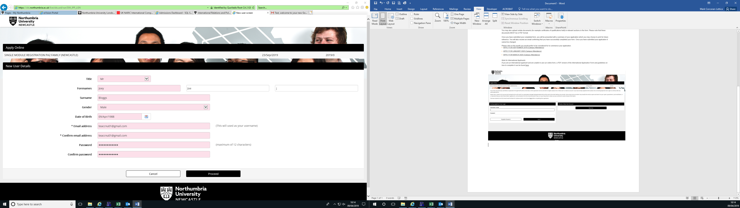

Once you have either logged in or created your new account, you will be able to start working through the series of tabs and filling out your online application.

Personal Details tab - you will need to supply your full name and details, as well as your home and contact address. Your home address should be your residential address, while your contact address should be your place of work.
We ask about disability status so that we can ensure appropriate reasonable adjustments are put in place in a timely manner, before you commence studies.
You are required to declare any criminal convictions. All offers of places on this course are made subject to an enhanced DBS check.

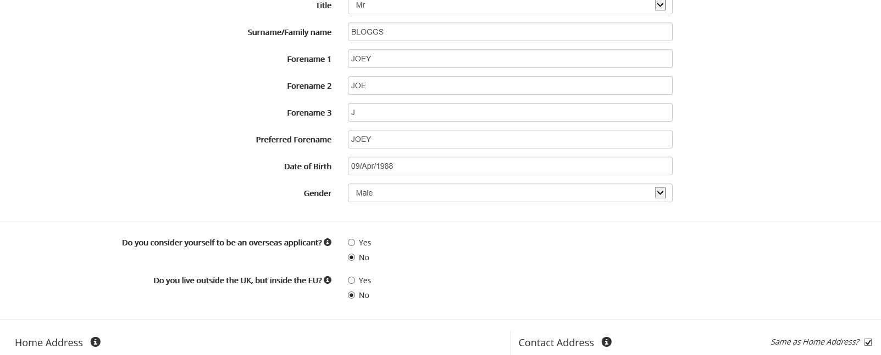

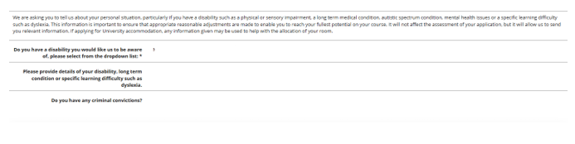Professional Memberships – application to this course is restricted to currently registered nurses, social workers, occupational therapists, and psychologists, so this section must be populated. Enter yes, then give the name of your professional regulator (i.e. SWE, NMC, HCPC etc.), then give your registration number.



Education tab – you need only add qualifications relevant to your application to this programme, such as your qualifying degree or equivalent. If you have passed either of the Northumbria University modules SW0740 Law and Practice for Best Interests Assessors or SW7009 Law and Practice for Best Interests Assessors, indicate so here. Please use the upload link to send a scan of certificates/ transcripts/ letters of confirmation, we cannot accept your application without these.
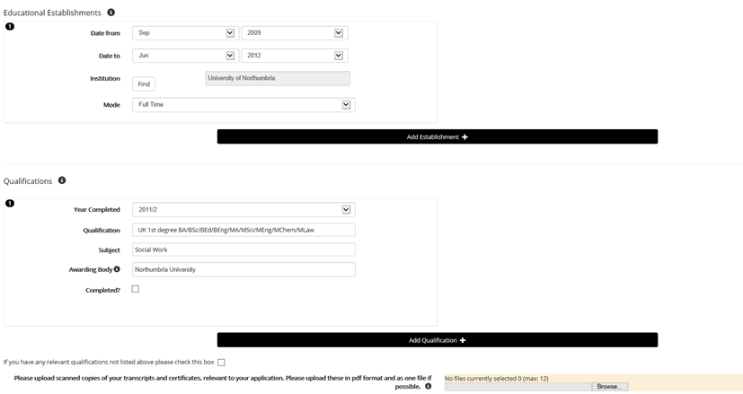

Work Experience tab - you do not need to detail your entire work history, but you must provide evidence that by the time the programme begins, you will have had a minimum of two years’ post-qualified practice.
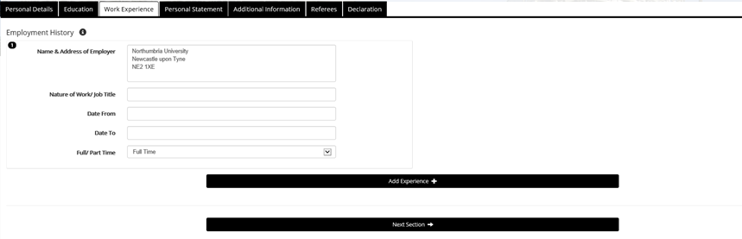

Personal Statement tab – PLEASE LEAVE BLANK. The upload link should be used to provide your personal statement as a word/pdf document. See guidance at Appendix 2.
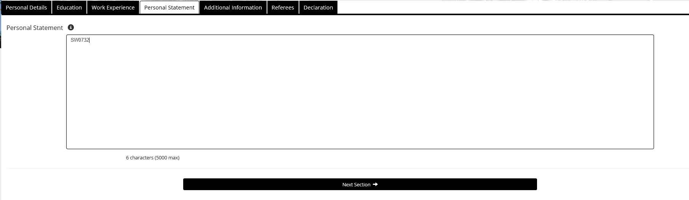

Additional Information tab - Please confirm, if appropriate, who is financially sponsoring your tuition fees if your application is successful. As this is a one-year programme, the answer to the ‘Further Information’ question is always no,.
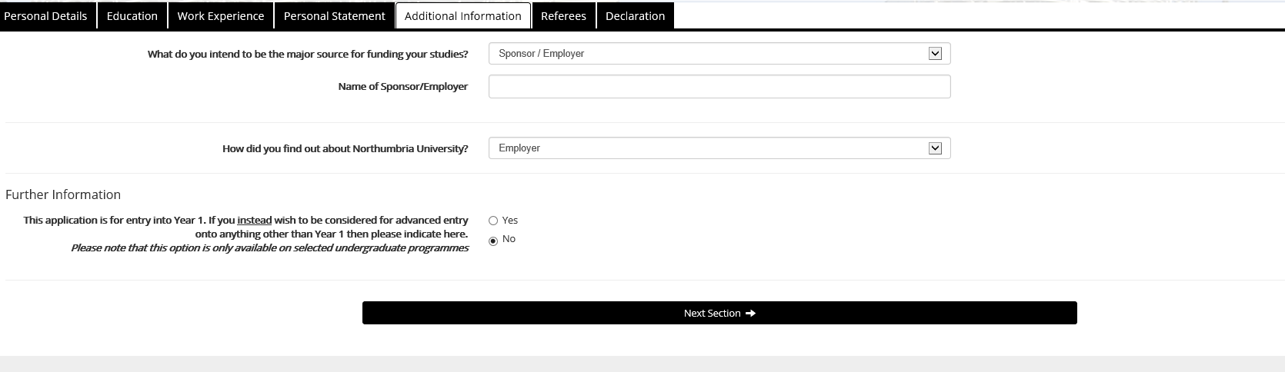

Referee tab – References are NOT required, so you should enter ‘N/A’ in this field.
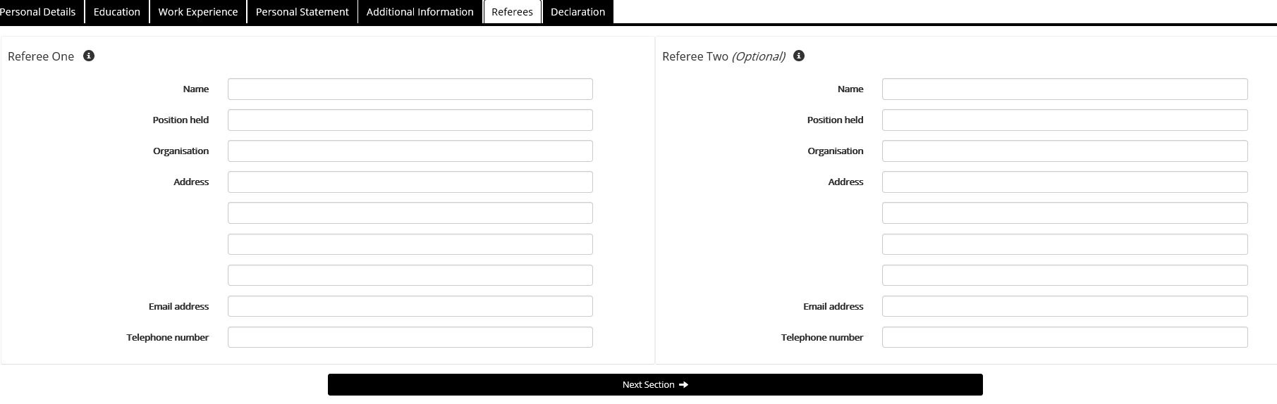

Declaration tab - you have the option either to save your partial application to complete later, or if it is complete, accept the Northumbria University conditions and submit your application. After you submit your online application, you can continue to upload other documentation to it via your Applicant Portal.

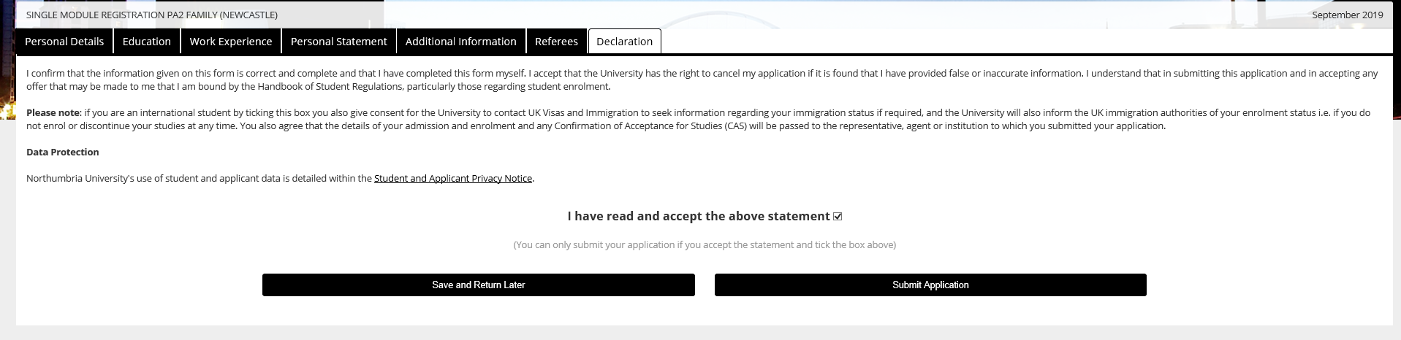

Appendix 2 Personal Statement
You DO NOT need to complete a personal statement if you can evidence that you have successfully completed either of the following two Northumbria university modules which demonstrate your potential to work towards demonstrating the AMHP competencies:
- SW7009 Law and Practice for Best Interests Assessors
- SW0740 Law and Practice for Best Interests Assessors

All other applicants ARE REQUIRED to write a personal statement of no more than 1,500 words, setting out their potential to acquire and demonstrate the AMHP competencies set out in Schedule 2 of the AMHP Regulations (England).

Personal statements should be grammatically written, and reference 2-3 credible and appropriate sources (Section 1 of this document incorporates links to a number of appropriate sources you may find useful).

Personal statements will be reviewed by the PG Cert Academic Lead and Lived Experience Lead. Each applicant will receive the Lived Experience Lead’s feedback on their suitability.

Please use the upload your personal statement to your online application as a word document or pdf.

Appendix 3 Practice Learning Audit Checklist
The document overleaf should be completed by the appropriate person within the sponsoring agency (often this is the AMHP Lead/Workforce Development Lead), and emailed to the PG Cert AMHP academic lead: cat.meredith@northumbria.ac.uk for review. The PG Cert AMHP academic lead will contact the person who completed the form for further information or clarification of arrangements if needed.

Once the proposed arrangements have been determined appropriate, audit check lists will be logged with the University’s Practice Placements Team, who will check whether the University holds a current health and safety risk assessment in respect of the sponsoring agency. If no current assessment exists, the sponsoring agency will be contacted to arrange completion of such.

Quality Assurance of Practice Learning Arrangements
Applicant name

Sponsoring agency

The applicant is employed |  | Full Time |  |  |  |  |  |  | Part Time
Proposed AMHP practice learning setting
Name and address of proposed practice learning setting
Name, email, and telephone number of team manager
Team’s primary function |  | Community Mental Health |  |  |  |  |  | Dedicated AMHP Team
 |  | Inpatient Mental Health |  |  |  |  |  | Other (please detail below)
Team working pattern |  | Office hours |  |  |  | Shifts
The proposed practice learning setting can provide opportunity to: |  |  |  |  |  |  |  |  |  |  |  | Yes | No
Work with and learn from a broad range of people experiencing mental distress.

Work alongside and learn from other team members and AMHPs.

Work with and learn from other mental health professionals, teams, and services.

Practice within the frameworks of the Mental Health Act, Mental Capacity Act, and Human Rights Act.
Practice from a social model.

Demonstrate the regulatory AMHP Competencies.

Safe and Inclusive Working Practices
The following policies and procedures are implemented and monitored within the proposed practice learning setting, and the student will be fully oriented to these as part of an induction: |  |  |  |  |  |  |  |  |  |  |  | Yes | No
Health and Safety

Equality, Diversity, and Inclusion

- Reasonable adjustments can and will be made to accommodate any disabilities, specific learning differences, or social or communication differences that the student may have.
Whistleblowing

- All offers of places on this course are made subject to enhanced DBS clearance. Are there any fitness to practice concerns about this applicant?
- Please confirm that if any fitness to practise issues arise during the course of study, the sponsoring agency will promptly share these with the academic lead.
Proposed Supervision and Assessment of AMHP Practice Learning
The person who will supervise and assess the student’s practice has: |  |  |  |  |  |  |  |  |  |  |  | Yes | No
Appropriate enhanced DBS clearance

Current, active and unrestricted registration with their professional regulatory body

An academic qualification in AMHP

A minimum of 2 years’ practice experience as an AMHP

Current approval under s.114 Mental Health Act 1983

Completed on behalf of sponsoring agency by

Name |  |  |  | Job title
Email |  |  |  | Date
For completion by the PG Cert AMHP Academic Lead
Notes
Date passed to Practice Placements Team

Appendix 4 Confirmation of Financial Sponsorship
If tuition fees are to be paid by an employer, the proforma provided overleaf should be cut and pasted into a Word document, completed by someone with appropriate managerial and budgetary authority. The completed document should be emailed to the Academic Lead – cat.meredith@northumbria.ac.uk and copied to the applicant, who should upload when completing enrolment.

FINANCIAL SPONSOR LETTER FOR PG CERT AMHP

To confirm financial sponsorship status, please provide information as directed below:
Name of Applicant(s): | Click or tap here to enter text.
Name of Course and Course Fee: | PG Cert AMHP - £3,233
Name of Organisation: | Click or tap here to enter text.
Organisation Contact: | Click or tap here to enter text.
Organisation Contact E-mail: | Click or tap here to enter text.
Organisation Contact Telephone: | Click or tap here to enter text.
Purchase Order Number: | Click or tap here to enter text.
Organisation VAT Registration Number: | Click or tap here to enter text.
Invoice Address: | Click or tap here to enter text.  Click or tap here to enter text.  Click or tap here to enter text.  Click or tap here to enter text.  Click or tap here to enter text.
Organisation Stamp/Letterhead: | Click or tap here to enter text.
Authorising Staff Member Signature: | Click or tap here to enter text.

All fields (other than Organisation VAT Registration number if not applicable) must be completed for this document to be accepted.

Payment Terms – All invoices should be paid in 30 Days of the invoice date. Delay in making payments could lead to students losing access to the university facilities. If the university does not receive a financial sponsorship letter, the student will be invoiced and would be held liable for paying the fees.
If you have any queries, please contact us at nsbackoffice@northumbria.ac.uk.

Changes to MHA in 2007 broadened out the original role of Approved Social Worker (ASW), allowing certain other professionals to be approved, and therefore replacing the ASW role with that of AMHP. Northumbria University began delivering a PG Cert ASW in 1992, and in line with the legislative changes, this subsequently became the PG Cert AMHP.
We are pleased to say that so far, this has never happened!
So long as places are available – see section 3.5

