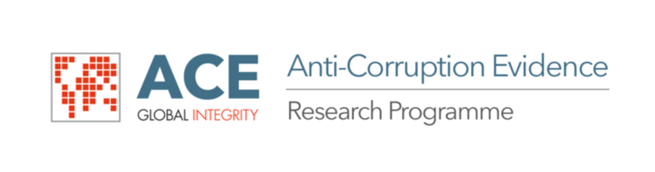
Practical interventions for uncovering and identifying beneficial ownership as a mechanism to recover the proceeds of corruption – a case study of Nigeria’.

Workshop Date: 29-30th July, 2019
Workshop Venue: Reiz Continental Hotel, Abuja

Monday 29th July 2019 | Programme
08.45 – 09.00 | Registration, Refreshments and networking
09.00 – 09.15 | Formal conference open Professor Abdullahi Shehu
09.15 – 10.45 | Group 1 presentations and discussion:  Corporate Affairs Commission (CAC);  Securities and Exchange Commission (SEC); and,  The Land Registry of the Federal Capital Territory.
10.45 - 11.15 | Coffee break
11.15 – 13.15 | Group 2 presentations and discussion:  Nigerian Financial Intelligence Unit (NFIU);  Central Bank of Nigeria (CBN)  The Special Control Unit against Money Laundering (SCUML)
13.15 – 14.00 | Lunch
14.00 – 15.45 | Group 3 presentations and discussion:  The Nigeria Police Force;  The Economic and Financial Crimes Commission; and,  The Independent Corrupt Practices and Other Related Offences Commission (ICPC)
15.45 – 16.00 | Tea break
16.00 – 17.00 | Main areas that have emerged from day one
17.00 | Close of day one
Tuesday 30th July 2019 | Programme
08.45 – 09.00 | Refreshments and networking
09.00 – 09.15 | Recap from day 1
09.15 – 10.45 | Group 4 presentations and discussion:  The Federal Ministry of Justice;  The Code of Conduct Bureau (CCB)
10.45 – 11.15 | Coffee
11.15 – 13.00 | Discussion of overall areas and emergent issues
13.00 – 13.45 | Lunch
13.45 - 15.00 | Project team presentation and discussion
15.00 – 15.15 | Tea break
15.15 - 16.30 | Discussion of next steps, delegate feedback and workshop conclusion
16.30 | Formal event close

