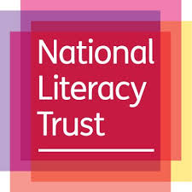

Leading Learning in Literacy
Northumbria University – Coach Lane Campus West
Friday 10th January 2020
8.45– 9.15: Registration and Refreshments
9.15 – 9.30: Welcome and background to the programme
Joanne Clifford Swan, Northumbria University
9.30– 10.30: ‘Literacy for Learning’
Nisha Tank, National Literacy Trust
10.30 – 11.00: Refreshments and networking
11.00 – 12.15: ‘Closing the Vocabulary Gap'
Alex Quigley explores the challenge at the heart of the school curriculum - our pupils access to the crucial academic language of school. First, he explores the evidence that attends the vocabulary gap, before going on to share practical solutions for teachers. The final 15 minutes will be dedicated question time
12.15 – 13.00: Lunch
13.00 – 14.15: ‘Putting it into practice’
Schools involved in the Northumbria University Literacy Project will each deliver a workshop detailing how they have approached aspects of whole school literacy development. Delegates will choose two of these workshops.
14.15 – 14.30: Refreshments
14.30 - 15.30: 'Tackling the challenge of whole school literacy'
Alex Quigley presents the challenges and opportunities of tackling literacy in our schools, ranging from talk, reading and writing. He recognises why many attempts to implement whole school literacy fail, before offering strategies to succeed.
15.30 – 16.00: Opportunity for Panel questions, discussion and feedback

