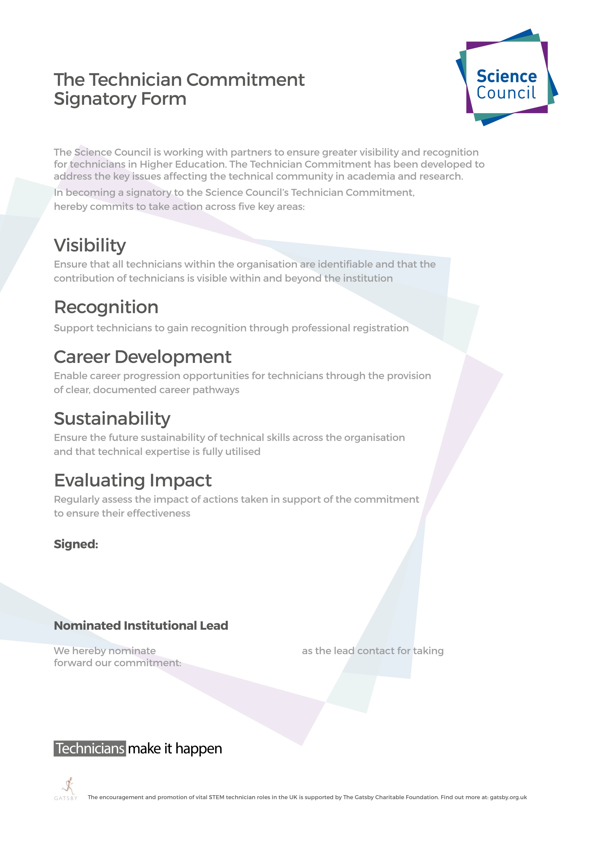

Northumbria University

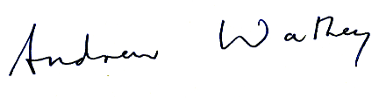

Professor Andrew Wathey, Vice-Chancellor and Chief Executive
Northumbria University
27 October 2021

Professor Louise Bracken

louise.bracken@northumbria.ac.uk
Pro Vice-Chancellor (Research)
0191 2437406

