From: Beth Lenney <beth.lenney@northumbria.ac.uk> On Behalf Of Tom Lawson
Sent: 08 November 2022 10:02
To: NU All Staff2 <nuallstaff2@livenorthumbriaac.onmicrosoft.com>; SU Staff and Sabbaticals <SUStaffandSabbaticals@northumbria.ac.uk>
Subject: Update from the Deputy Vice-Chancellor, Professor Tom Lawson

This message is being sent to all colleagues

Dear Colleagues

I wanted to write to tell you about some of the things we are doing in the context of the current, very challenging, cost of living pressures facing colleagues and in particular in relation to pay levels.

The national collective pay bargaining process is complex and challenging for all parties. We know that cost of living pressures are being faced by everyone employed in the sector but the circumstances facing each institution are hugely variable. We contributed to the UCEA consultation earlier this year however we are one voice in approximately 150 and the negotiators didn’t get a mandate to increase their pay offer when it last consulted with participants. As a consequence for most salary points a 3% uplift was applied from 1 August 2022.

You will be aware from Jane Embley’s portfolio update on 6 October 2022, that the University is already in discussions with UNISON about some positive changes which: address low pay and the compression of salary points at Grades 1-3, harmonise leave entitlements with academic staff and allow colleagues to ‘sell’ leave. We are moving as quickly as we can and are hopeful that we will reach agreement with UNISON to enable improvements to be implemented in December, with pay increases backdated to 1 August 2022. The value of the payment for one week of leave if sold is 1.92% of an individual’s annual salary and this change is intended as a long term one which provides flexibility and choice for individuals.

These proposals have been carefully constructed so as not to undermine the University’s participation in national collective bargaining, a decision which both UCU and UNISON have supported in the past. We are now considering whether a similar arrangement might be possible in relation to academic staff. Again we need to avoid an approach which undermines or disallows Northumbria from participating in future rounds of national pay bargaining and therefore we need to come up with a way forward which keeps us on the right side of that process but responds to the current situation in a way we feel is right for colleagues at Northumbria.

We have asked the Branch Chair of the Northumbria UCU Branch to meet with us to discuss a local agreement to pay a further non-consolidated 3% monthly supplement on current salaries from 1 January 2023. This would amount to a 6% uplift on salaries from the position in 2021/22 from January. We are making this proposal because we do not feel there will be any movement soon on a consolidated increase as a result of the national negotiations and we want to take action now. The supplement would be payable between 1 January and 31 July 2023 at which time next year’s national increase would be known and could be implemented. The nationally agreed increase from 1 August 2023 would then take the place of the additional 3% supplement we are proposing.

We have gone on record as not supporting one off payments, which have been paid in some institutions, as we feel they are reactive, short term and unpredictable. We want our colleagues to have confidence that if their monthly income increases this will be regular and sustained.

As this proposal would go a long way to address the current dispute on pay it would require the Northumbria UCU Branch to agree not to participate in the nationally organised industrial action to be implemented. Our aim is a local agreement which addresses pay concerns and avoids industrial action which no one wants and we know is very damaging for our students.

We will keep you updated about our discussions with UCU. If agreed the additional supplement will be applied to all staff groups and salary points up to and including Grade 9 except the points under discussion with UNISON which will have already been adjusted. This offer will mean that colleagues employed at Northumbria from 1 January 2023 who are not covered by the agreement with UNISON will have received from August 2022 to December 2022 an uplift of 3%, and from January to July 2023 will receive an uplift of 6%, on their 2021/22 salary. In the current financial climate, with our own institutional pressures around rising energy costs and inflation, we believe that would be a positive outcome for everyone concerned.

I will write to update you on conversations with UCU as they develop, in the meantime we will prepare to mitigate the impacts of any industrial action on our students, should an early agreement with UCU not be possible.

All best

Tom

Professor Tom Lawson, FRHistS
(he/him)

Deputy Vice-Chancellor

M: +44 (0) 7590 629 215
E: tom.lawson@northumbria.ac.uk

Executive Assistant: Beth Lenney
T: +44 (0)191 227 7400
E: beth.lenney@northumbria.ac.uk

Author - The Last Man: A British Genocide in Tasmania
Editor - Holocaust Studies: A Journal of Culture and History

Latest Publication: The Palgrave Handbook of Britain and the Holocaust
Sutherland Building, Northumbria University, Newcastle upon Tyne, NE1 8ST, United Kingdom

I do not expect others to keep the same work hours as I do, so please respond in your regular working hours

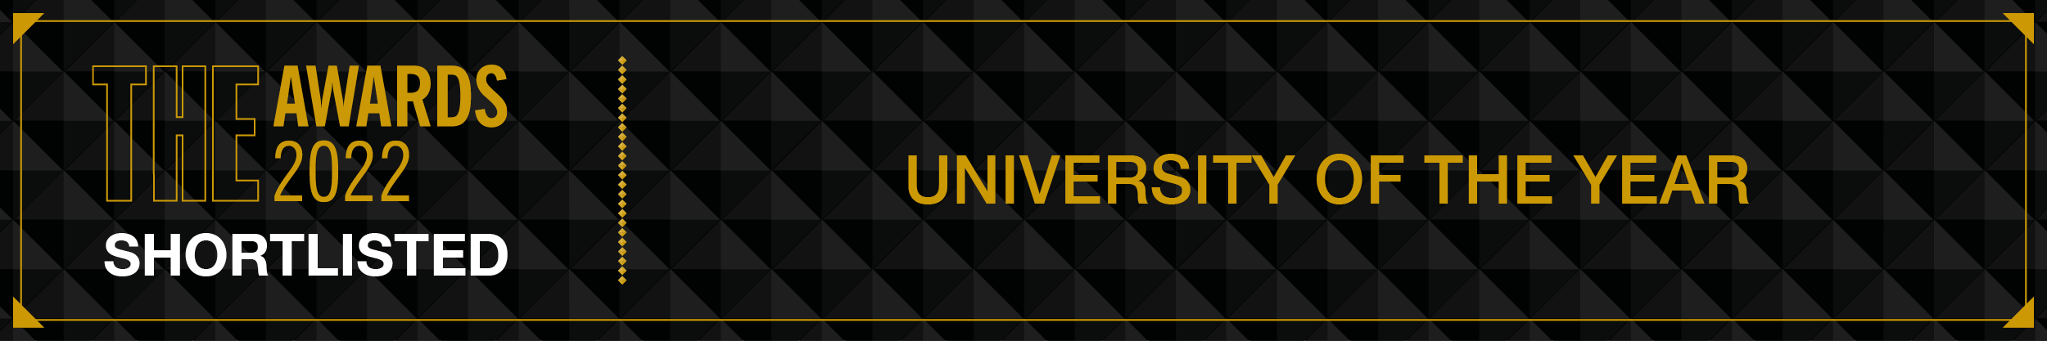

 | 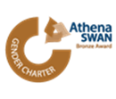 |  |  |  | 