Researcher Development Personal Planner
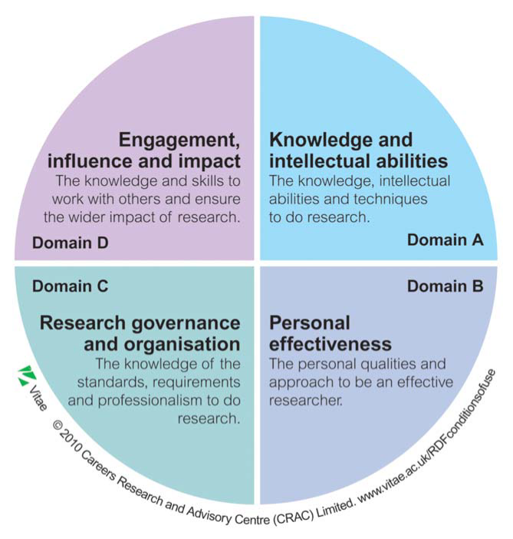
Complete this self‐evaluation annually to support your Professional Researcher Development and Training Programme selection.

Indicate your skill level against each of Vitae’s Researcher Development Framework domains and use the results to plan your professional development.

Example

Indicate your current skill level and where you would like it to be in one year.
Use these spaces to reﬂect on your current situation and plan which session(s) and other actions will help you achieve your target

 |  | C | Current phase
Domain A: Knowledge and intellectual abilities |  | T | Target phase
 |  | 1 | 2 | 3 | 4 | 5
1 Knowledge base | Subject knowledge | C | C | C | T | T
 | Research methods: theoretical knowledge | C | C | T | T

RDF Researcher Proﬁle
Name:

Current situation and background: Career aim:
Timeframe for development plan:
 |  | C | Current phase
Domain A: Knowledge and intellectual abilities |  | T | Target phase
 |  | 1 | 2 | 3 | 4 | 5
1 Knowledge base | Subject knowledge
 | Research methods: theoretical knowledge
 | Research methods: practical application
 | Information seeking
 | Information literacy and management
 | Languages
 | Academic literacy and numeracy

2 Cognitive abilities | Analysing
 | Synthesising
 | Critical thinking
 | Evaluating
 | Problem solving

3 Creativity | Inquiring mind
 | Intellectual insight
 | Innovation
 | Argument construction
 | Intellectual risk

RDF Reﬂections
 |  | C | Current phase
Domain B: Personal eﬀectiveness |  | T | Target phase
 |  | 1 | 2 | 3 | 4 | 5
1 Personal qualities | Enthusiasm
 | Perseverance
 | Integrity
 | Self‐conﬁdence
 | Self‐reﬂection
 | Responsibility

2 Self‐management | Preparation and prioritisation
 | Commitment to research
 | Time management
 | Responsiveness to change
 | Work‐life balance

3 Professional and career development | Career management
 | Continuing professional development
 | Responsiveness to opportunities
 | Networking
 | Reputation and esteem

2 Research management | Research strategy
 | Project planning and delivery
 | Risk management

RDF Reﬂections

 |  | C | Current phase
Domain C: Research organisation and governance |  | T | Target phase
 |  | 1 | 2 | 3 | 4 | 5
1 Professional conduct | Health and safety
 | Ethics and principles
 | Legal requirements
 | IPR and copyright
 | Respect and conﬁdentiality
 | Attribution and co‐authorship
 | Appropriate practice

3 Finance, funding and resources | Income and funding generation
 | Financial management
 | Infrastructure and resources

2 Communication and dissemination | Communication methods
 | Communication media
 | Publication

3 Engagement and impact | Teaching
 | Public engagement
 | Enterprise
 | Policy
 | Society and culture
 | Global citizenship

RDF Reﬂections
 |  | C | Current phase
Domain D: Engagement, inﬂuence and impact |  | T | Target phase
 |  | 1 | 2 | 3 | 4 | 5
1 Working with others | Collegiality
 | Team working
 | People management
 | Supervision
 | Mentoring
 | Inﬂuence and leadership
 | Collaboration
 | Equality and diversity

