From: Northumbria Announcements <it.announce@northumbria.ac.uk>
Sent: Tuesday, May 16, 2023 9:00 AM
Subject: An update on Industrial Action from Professor Tom Lawson

This message is being sent to all academic staff on behalf of Professor Tom Lawson, Deputy Vice- Chancellor.

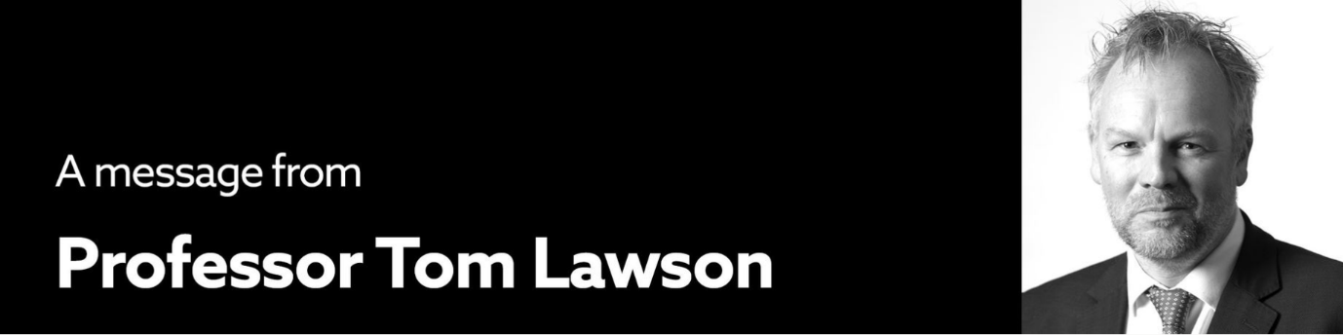
Dear Colleagues

Further to my e-mail of 19 April 2023, I thought it would be useful to remind you of the arrangements we have put in place during UCU’s marking and assessment boycott to limit the impact of the action on our students so they can graduate or progress to the next year of study.

Colleagues participating in the marking and assessment boycott

I would like to thank colleagues who have already completed their online notification. If you are participating in the marking and assessment boycott you must complete an online notification on the date you decide to participate in the action. You will be paid your normal salary until the date you are due to submit marks (for clarity this is your individual marks submission deadline, not the universal University marking deadline (9 June 2023), unless the two dates coincide).

Pay will be withheld continuously from this date until the date you complete a further online notification to confirm you have resumed your full duties or the date all marks are able to be confirmed. Subject to there being no delay to confirming marks at the Programme Assessment Boards, this is expected to be on or around 23 June 2023. Some Programme Assessment Boards may need to be moved in order to ensure that all marks can be confirmed and pay will, in those circumstances, be withheld until any boards that do move have been completed.

The University reserves the right to withhold 100% pay for Action Short of a Strike (ASOS). However, we have taken a position in relation to pay which we hope both respects the right of colleagues to participate in the action but encourages everyone to work together to minimise the impact of the action on our students at Northumbria.

The University will make a discretionary payment of 50% for the days on which your pay has been withheld where you:

- Use the online notifications at the start and end of any period of participation (as explained above).
- Cooperate fully with requests for information which allow mitigation plans to be made.
- Voluntarily continue to perform other aspects of your role, such as research.

Pay will be at normal levels on weekends, bank holidays and days you are on annual leave.

Colleagues not participating in the marking and assessment boycott

Colleagues who do not intend to take part in the boycott are encouraged to inform their Head of Department. In some departments colleagues may be asked to reprioritise activities to enable to additional marking to be undertaken.

We are focusing on minimising the disruption over this period and may ask colleagues to undertake additional marking to cover for those participating in the action. Colleagues who agree to undertake additional marking will be supported to re-prioritise their work to enable the additional marking to be completed working, wherever possible, to achieve the 20 day turnaround we promise to students. For clarity this period is the maximum period a student waits from the submission date to receive their marks and feedback, not the length of time colleagues have to undertake marking. Where this work is over and above a current, full workload and reprioritisation isn’t possible, an individual’s 2023/24 workload allocation will be adjusted to recognise any additional marking and assessment activity carried out this academic year.

Colleagues who have completed their existing work but are unable to undertake additional marking will not be considered as participating in the marking and assessment boycott.

Maintaining the integrity of our awards

Maintaining the integrity of our awards and supporting students to achieve the assessment outcome they have worked for is our priority during this period. The University has robust policies in place to maintain the integrity of our awards and all marking will be undertaken by individuals who are appropriately qualified.

Next steps

It is disappointing that our students continue to be impacted by the dispute when the sector’s 2023-24 pay uplift is comparable to settlements in the wider economy and some of the uplift was paid six months earlier than usual. Most HE institutions continue to face considerable financial uncertainty, and many are operating with financial deficits. While Northumbria continues to pay many colleagues a non-consolidated supplement of 1% above the national settlement, there is no sign of the sector being in a position to make an increased pay offer.

UCU members will understandably want to share widely the reasons for their industrial action. This must be done via established channels such as demonstrations and noticeboards and not by approaching students while they are working quietly, online via the VLE or using any of the other resources and facilities provided by the University.

Please review the online FAQs for more information on the marking and assessment boycott, clarification on the 20 day turnaround period for student assessment and feedback and other information about the industrial action. If you have any questions, please do not hesitate to contact your Head of Department, Faculty Pro Vice-Chancellor, or me.

All best,

Tom

Professor Tom Lawson, FRHistS
(he/him)

Deputy Vice-Chancellor

