From: Northumbria Announcements <it.announce@northumbria.ac.uk>
Sent: Friday, June 9, 2023 9:37 AM
Subject: An update on Industrial Action from Professor Tom Lawson

This message is being sent to all academic staff on behalf of Professor Tom Lawson, Deputy Vice- Chancellor.

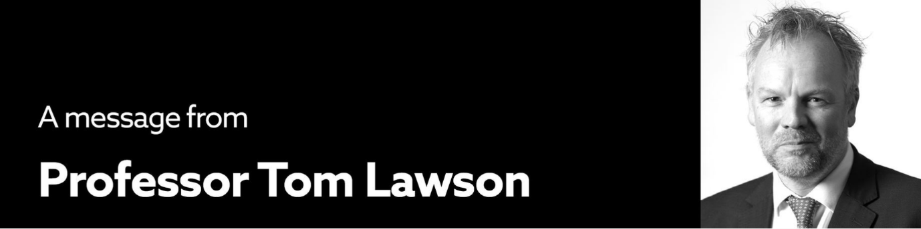
Dear Colleagues

Further to my previous e-mail dated 16 May 2023, I thought it would be useful to remind you of the arrangements we have put in place during UCU’s marking and assessment boycott to limit the impact of the action on our students so they can graduate or progress to the next year of study.

Colleagues participating in the marking and assessment boycott up to 23 June

135 colleagues have completed an online notification to indicate that they are participating in the marking and assessment boycott with the vast majority of this number in four of our 19 academic departments.

Our previous communications explained that pay would be withheld for a period from the individual’s marks submission date to the end of the assessment period. Following feedback and with the experience of seeing how patterns of activity and notifications have materialised across departments we have decided to simplify the approach and withhold pay for a two-week period for everyone who has participated in the action. This will cover participation from the start of the boycott on 20 April up to 23 June which is the general marks release date for Semester 2 assessments.

Pay will be withheld for two weeks in June at 100% and a voluntary payment of 50% for two weeks will be made for those who have, in a timely way, advised us of their participation via an online notification. My previous email explained what was required to receive this voluntary payment.

The University continues to reserve the right to withhold 100% pay for Action Short of a Strike (ASOS), however, on this occasion, has taken a position in relation to pay which both respects the right of colleagues to participate in the action but encourages everyone to work together to minimise the impact of the action on our students at Northumbria.

In relation to the period up to 23 June, colleagues who have participated in the boycott but have not advised the University via a timely online notification will have two weeks pay withheld at 100% in June, where this information is known at the time of the June payroll cut off, or in July.

Colleagues participating in the marking and assessment boycott after 23 June

The University reserves the right to withhold pay at 100% where colleagues continue to participate in the boycott after 23 June and where marking remains outstanding. Where marks are still outstanding for progressing students, the University will require those marks to be returned by a revised deadline of 7 July. In the event that colleagues participating in the MAB do not return these marks then pay will be withheld for a further period to reflect this.

Colleagues participating in the marking and assessment boycott up to 23 June and then resuming full duties after this date

If you wish to resume your full duties from 23 June, which will include undertaking any marking that is outstanding, you must complete an online notification, on or before this date, to indicate that you are working as normal. As soon as you return to your full range of duties you will face no further periods of pay being withheld.

Colleagues not participating in the marking and assessment boycott

I would like to thank colleagues who have worked hard to complete marking in time for the Assessment Boards. Many of you have reprioritised your work and undertaken additional marking to help to minimise the disruption caused by UCU’s action and I, my colleagues, and our students are very grateful for your support.

As promised, where this additional work is over and above your current, full workload and reprioritisation hasn’t been possible, your 2023/24 workload allocation will be adjusted to recognise the additional marking and assessment activity carried out this academic year.

It remains disappointing that our students continue to be impacted by UCU’s dispute. The Sector’s 2023-24 pay uplift is comparable to settlements in the wider economy and some of the uplift was paid six months earlier than usual. As has been widely reported, most HE institutions continue to face considerable financial uncertainty, and many are operating with financial deficits. While Northumbria continues to pay many colleagues a non-consolidated supplement of 1% above the national settlement, there are no signs of UCEA, on behalf of the sector, being in a position to make an increased pay offer.

If you have any questions, please do not hesitate to contact your Head of Department, the Pro Vice-Chancellor for your Faculty, or me.

All best,

Tom

Professor Tom Lawson, FRHistS
(he/him)

Deputy Vice-Chancellor

