PRIMARY PARTNERSHIP AGREEMENT 2021-22
By signing this agreement, we agree to undertake our roles and responsibilities as set out in the Primary Partnership Handbook.
Name of School:

Address:

Signed on behalf of school:

Position in school:

Please print name of signatory:

Date:

Signed on behalf of Northumbria University:
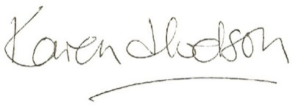
Head of Subject: Education, Children and Young People
Date: September 2021
Please sign two copies and return one via e-mail to hl.placements.education@northumbria.ac.uk
Please keep the other copy for your records.

