From: Tom Lawson <tom.lawson@northumbria.ac.uk>
Sent: Friday, July 21, 2023 12:32 PM
To: NU All Academic Staff <nuallacademicstaff@livenorthumbriaac.onmicrosoft.com>
Subject: Marking and Assessment Boycott Update

Dear Colleagues
The assessment and marking of our undergraduate students’ work is now complete. All our graduating students have fully classified awards, and progression has been confirmed for all continuing students. Some progressing students in two academic departments have missing marks on their profile and have progressed on a no detriment basis.
Participation in the marking and assessment boycott between 23 June and 7 July
Twelve colleagues from one academic department notified the University that they were participating in the marking and assessment boycott between 24 June and 7 July and pay will be withheld in July for these colleagues in line with my e-mail dated 30 June. Colleagues who notified the University of their participation in the boycott after the payroll deadline (13 July) will have their pay withheld in August.
The University reserves the right to determine the status of colleagues, as participating or not in the marking and assessment boycott, and make retrospective deductions, where it becomes clear at a later date that an individual has not indicated their participation yet have not completed their marking by the agreed deadline.
As far as the University is concerned we have now reset the position for the Marking and Assessment Boycott and all colleagues who have previously notified the University that they are participating in the action will return to full pay from 8 July.
Outstanding marks for progressing students will be expected to be completed but will not be being actively sought at this time. This decision has been made to alleviate some of the workload pressures and enable colleagues to enjoy their usual summer activities.
Participation in the marking and assessment boycott from 14 July onwards
Work continues to be submitted in relation to other cohorts across the summer. Colleagues who wish to continue to participate in the boycott in relation to work submitted during this period, are required to notify the University of their participation via the online notification. A second online notification is required to confirm full duties, including those relating to marking and assessment activities, have been resumed. Pay will be withheld during this period at 100% but the University will make a voluntary payment of 50% of salary where colleagues inform us in a timely manner to allow marking to be reallocated, as per previous arrangements.
This sustained period of industrial action is having a significant impact on many colleagues and the University welcomes the news that UCEA, UCU and the other recognised trade unions began talks last week to explore how to resume negotiations and bring an end to the Marking and Assessment Boycott. I will update you further on the outcome of these discussions as the situation develops.
Further information in relation to the industrial action and the position on pay as set out in previous correspondence is available on our FAQs.
All best
Tom
Professor Tom Lawson, FRHistS
(he/him)

Deputy Vice-Chancellor

M: +44 (0) 7590 629 215
E: tom.lawson@northumbria.ac.uk

Executive Assistant: Caroline Gray
T: +44 (0)191 227 7400
E: c.gray@northumbria.ac.uk

Author - The Last Man: A British Genocide in Tasmania

Latest Publication: The Palgrave Handbook of Britain and the Holocaust
Sutherland Building, Northumbria University, Newcastle upon Tyne, NE1 8ST, United Kingdom

I do not expect others to keep the same work hours as I do, so please respond in your regular working hours

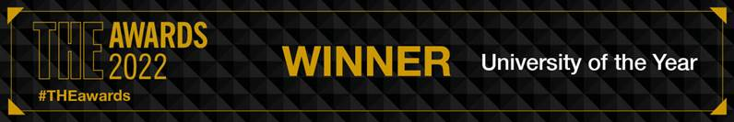

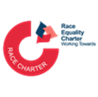 | 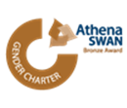 |  |  |  | 