From: Northumbria Announcements <it.announce@northumbria.ac.uk>
Sent: Friday, June 23, 2023 3:24 PM
Subject: A message from Professor Tom Lawson - Results Day

This message is being sent to all academic staff on behalf of Professor Tom Lawson, Deputy Vice- Chancellor

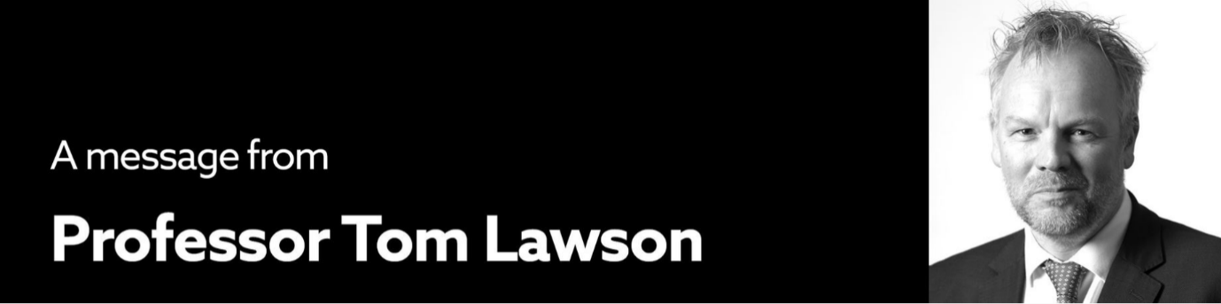
Dear Colleagues,

Further to Jane Embley’s e-mail dated 21 June, I thought it would be useful to provide an update on the position in relation to the release of degree outcomes for students in the context of UCU’s marking and assessment boycott, how colleagues can update their status if they have ended their participation, what will happen between now and 7 July and where colleagues can go to access support.

Release of degree outcomes to Northumbria Students
Today our final year students are receiving classified awards. This is a huge achievement. As you know it has been particularly challenging this year in a few of our academic departments where there were high levels of participation in the Marking and Assessment Boycott. I want to thank colleagues for their enormous efforts in these very difficult circumstances.

Colleagues who have been participating in the marking and assessment boycott up to 23 June and want to return to full duties from 26 June
For many today will be the last day of participation in the Marking and Assessment Boycott and a number of colleagues have already informed us of this. Colleagues who wish to return to working as normal and resume full pay from 26 June must complete an online notification to advise the University of this. If you have marking outstanding, you will be required to complete it. However, if someone has completed your marking, you will be able to return to working as you usually would at this time of year or take annual leave.

While the University has not required colleagues to complete the marking of staff participating in the boycott, it is only because so many have volunteered to do this that we are able to welcome participating colleagues back to full pay at this early stage. It is our goal to reach a position where all outstanding marking has been completed and all colleagues are back to full pay as soon as possible.

Colleagues who wish to continue to participate in the marking and assessment boycott after 23 June
Unless you complete an online notification, it will be assumed that your participation in the boycott is continuing. The University reserves the right to withhold pay at 100% where colleagues continue to participate in the boycott after 23 June. Where colleagues respond positively to reasonable requests the University will make a voluntary payment of 50% between 26 June and 7 July in recognition of other work undertaken, such as research.

Our students
The University deeply regrets the impact that the action has had on our students. We are communicating with those affected and have put arrangements in place so that any student who raises a concern is provided with support.

All marking is being undertaken by appropriately qualified academics and robust processes remain in place to protect the rigour and quality of our awards, including scrutiny by internal and external moderators and programme assessment boards. As ever, we have clear procedures in place for students to raise concerns where they believe there has been an error, or to ask any other questions.

Results are an important moment for our students, and any communications that misrepresent the rigour, quality, or integrity of the processes we have followed in assessing their work are without merit, will cause them distress, and are not acceptable to the University. Colleagues with legitimate concerns should raise them with their Head of Department.

Support for you
This sustained period of industrial action is having a significant impact on many colleagues. In addition to support from your line manager and Faculty leadership team, I would like to remind colleagues of the support service available should you find it helpful to speak to someone in confidence about your experience.

If you have any questions, please do not hesitate to contact your Head of Department, the Pro Vice-Chancellor for your Faculty, or myself.

All best,
Professor Tom Lawson, FRHistS
(he/him)
Deputy Vice-Chancellor

